Name ______________________________
History homework – the early peoples of Scotland
Task 1 – label the map with the four peoples of Scotland in around 650 A.D. putting them in the correct areas. Now shade in the areas each group lived in.
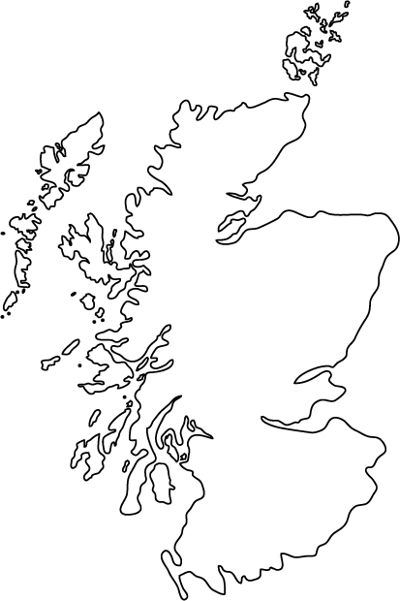

Task 2- write down the names of the four Pictish villages from the following jumbled up words.
MNDEEDTPI ERIDTOPIDT OILGSTIP MEWENTPTIE

Village 1 _______________________________________
Village 2 _______________________________________
Village 3 _______________________________________
Village 4 _______________________________________

Now, can you write down what this Pictish message says in English?
_________________________________________________________________________________________________________________________________________________________
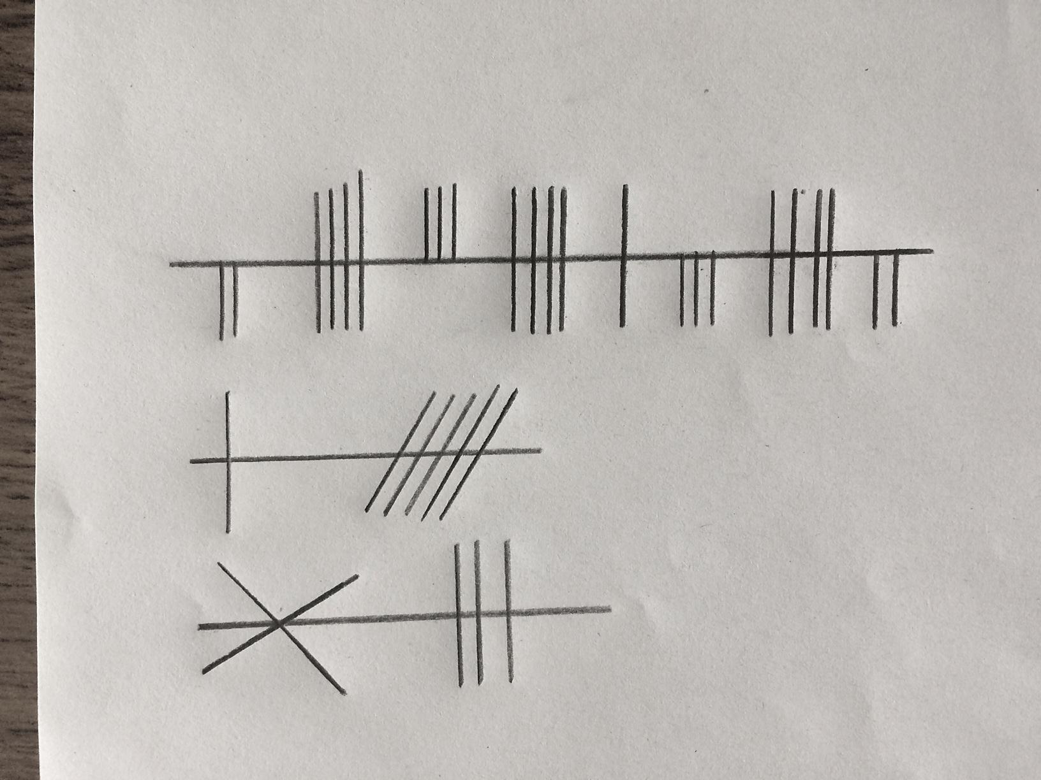

Parental signature _______________________________________

