How can we contribute to family life?
Look at how one family (who have one son and one daughter) share the various household responsibilities.
Cleaning the kitchen | Dad helped by daughter sometimes
Cleaning the bathroom | Mum
Cooking | Dad
Doing the ironing | Dad – sometimes other family members help out
Tidying the living area(s) | Son and daughter
Tidying bedroom(s) | Each does their own
Looking after pets | Daughter
Domestic shopping (food and cleaning products) | Mum
Jobs outside the house: gardening, car washing | Dad and son

Work individually and complete the chart below. You should try and ensure the tasks in the left-hand column are the kinds that you complete at home. You can use some of the examples already given. Write down who completes these tasks in your house.
Now think about how the tasks in your family were agreed in the first place and discuss the following questions:
- Did you choose your tasks, or were you told which tasks you had to do?
- Do you think the distribution of tasks in your family is fair?
- If you don’t do your task, does another family member always end up doing it for you?
It’ not just sharing out the tasks that can cause problems in a family. There can be all sorts of reasons for family rows and upsets. Here’s a list of some of the things that families find help their communal life to run more smoothly.
Showing affection
Respecting difference
Good communication
Give and take
Respecting boundaries/ rules
Keeping a sense of humour
Respecting personal space
Having patience
Doing things together (quality time)

Task:
Work together and discuss the speech bubbles above.
Construct a ‘diamond 9’ by ranking each item in a diamond like the one on the right. The item that you think is the most important should go at the top and the one you think is the least important should be at the bottom.
Make sure you discuss why you have ranked them in that order. 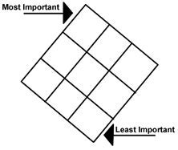
There are nine items in the speech bubbles. If you had to add a tenth one, what would it be?
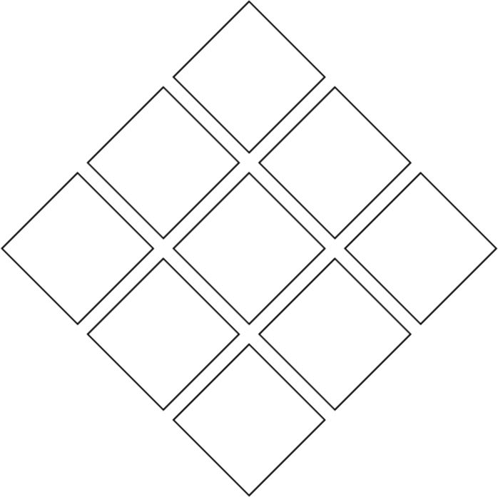

My tenth one would be:
___________________________________________________________________

