ACCESSING DIGITAL RESOURCES

As members of Aberdeenshire Libraries, all pupils have access to our online resources. All of these are free of charge. To access them, you need your library membership number and a pin number. If you do not know these, please email gw15fairweatherkathe@glow.sch.uk or katie.fairweather@aberdeenshire.gov.uk.

www.livelifeaberdeenshire.org.uk Select Libraries

(Select Library Catalogue to see your personal information and order/renew books. This is where you can change you Pin Number to one you will remember.)

From the main library page, select The Digital Library.

Overdrive
Once you input your membership number and pin, you have access to online e-books and audio books.
They can be borrowed for 21 days at a time and will automatically delete at the end of the loan period, but can be taken out again.

The books can be read or listened to in your browser but if you prefer, download the Libby app (from Google Play Store) to your phone. To will need to authenticate your account with your library service, (Aberdeenshire), membership number and pin.

RB Digital
Download audio books and magazines. Register using your library membership number and email address.

Press Reader
Keep up to date with current affairs or browse through your favourite magazines. Press Reader has newspapers and books from over 120 countries, in more than 60 languages. Pick your favourites and set up a home feed. You will be asked to register on a monthly basis, but that is all.

Freegal
Stream music up to 5 hours a day and download 5 of your favourites a week,

Databases
Perfect for research and revision as well as the driving theory test. Dawson Era for example, gives you access to study guides and past papers from the e-book collection. A must for pupils in S4 – 6.

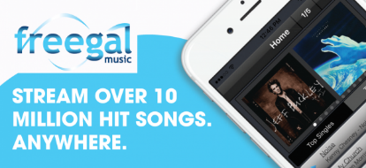 |  | 