Number Processes
MNU 3–03 I can use a variety of methods to solve number problems in familiar contexts, clearly communicating my processes and solutions

MTH 3-03b I can continue to recall number facts quickly and can use them accurately when making calculations

Place value of numbers
1. Write the following numbers in words:-
(a) 371 (b) 7030 (c) 130 240
(d) 41 005 (e) 1 805 000 (f) 2 040 800

2. Write the following numbers in figures:-
(a) nine thousand and eighty one
(b) fifty four thousand five hundred
(c) one hundred and fifty thousand and five
(d) four million, six hundred and two thousand, four hundred

How to add and subtract numbers with 5 digits in context
3. (a) 5768 + 6742 (b) 18 725 – 13 907

4. The population of Cederton is 40 000. Of this population there are 16 500 men, 14 800 women and the rest are children. How many children live in Cederton?

Multiply and divide integers by a single digit
5. (a) 207 x 6 (b) 1057 x 4 (c) 7273 ÷ 7 (d) 5175 ÷ 9

Multiply and divide by powers/multiples of 10
6. (a) 22 x 10 (b) 10 x 39 (c) 2020 x 10 (d) 34 x 100

7 (a) 20 ÷ 10 (b) 300 ÷ 10 (c) 1 000 000 ÷ 10 (d) 400 ÷ 100

8. (a) 32 x 30 (b) 41 x 60 (c) 12 x 300 (d) 30 x 9021

9. (a) 15 000 ÷ 60 (b) 7200 ÷ 30 (c) 9000 ÷ 500 (d) 520 000 ÷ 400

10. A fishing trip company stocks 320 jars of worms. Each jar contains 30 worms. How many worms in total does the company stock?

11. On a fish farm 24 000 fish are kept in 30 tanks.
If each tank has the same number of fish, how many fish are in each tank?

12. Alison estimated that she needed 36 000 ice cubes for a party. If ice cubes are sold in boxes of 400, how many boxes will be needed?

Carry out long multiplication
13. Calculate:
(a) 56 x 23 (b) 72 x 34 (c) 56 x 82

14. Calculate:
(a) 204 x 24 (b) 546 x 59 (c) 345 x 73

15. Calculate:
(a) 8204 x 29 (b) 4706 x 83 (c) 5302 x 46

Understand the order of operations
16. Calculate:
(a) 410 – 6 x 8 (b) 19 + 5 x 21 (c) 43 – 48 ÷ 6 (d) 4 x (28 + 72) (e) 18 x (29 – 18) (f) (27 + 23) ÷ 5

17. Calculate:
(a) 3 + 6 ÷ 3 x 2 (b) 5 x 3 – 12 ÷ 4 + 8
(c) 5 x 4 – 2 x 3 + 16 ÷ 4 (d) 30 – (5 x 8 – 15)
(e) (23 + 2) – 5 x 3 + 8 (f) (15 ÷ 3 + 4) – (9 – 7 x 2)
(g) (16 – 6 + 5) ÷ (9 + 8 – 7 x 2) (h) (27 – 2 x 7) + (5 x 3 – 4)

Fractions and Percentages
MNU 3-07a I can solve problems by carrying out calculations with a wide range of fractions, decimal fractions and percentages using my answers to make comparisons and informed choices for real life situations

MNU 3-07b By applying my knowledge of equivalent fractions and common multiples, I can add and subtract commonly used fractions

MTH 3-07c Having used practical pictorial and written methods to develop my understanding, I can convert between whole or mixed numbers and fractions

Show connection between equivalent fractions, decimals and percentages
1. Write each of the following as a fraction and as a decimal:
(a) 41% (b) 93% (c) 7% (d) 23%
(e) 99% (f) 11·5% (g) 1·5% (h) 8·25%

2. Write these percentages as fractions and simplify:
(a) 20% (b) 45% (c) 15% (d) 75%
(e) 5% (f) 35% (g) 66 2/3 % (h) 12·5%

3. Use a calculator where necessary and change each fraction to a percentage:
(a) 8 (b) 12 (c) 5 (d) 11
25 40 8 80
4. Andrew sat a Maths test which comprised of twenty questions each worth two marks.
Andrew scored 32 marks. Write his test score as a percentage.

Explain how to calculate a fraction of a quantity
5. Calculate:
(a) 1 of 46 (b) 1 of 39 (c) 1 of 64 (d) 1 of 63
2 3 4 7
(e) 1 of 84 (f) 1 of 165 (g) 1 of 880 (h) 1 of 975
12 15 20 75
6. Calculate:
(a) 3 of 36 (b) 2 of 24 (c) 3 of 21 (d) 4 of 35
4 3 7 5
(e) 9 of 210 (f) 5 of 144 (g) 7 of 648 (h) 11 of 143
10 12 8 13

7. Two thirds of the days in June were sunny days. How many days were sunny?

8. A computer predicted that in February 2007 two sevenths of the month would have snow falling. How many days would not have snow falling?

Show how to simplify fractions
9. Simplify each fraction:
(a) 10 (b) 5 (c) 3 (d) 4
20 25 12 24
(e) 8 (f) 6 (g) 16 (h) 250
30 45 48 600

Explain how to change from improper fractions to mixed numbers and vice versa
10. Change each of these top heavy fractions to mixed numbers:
(a) 15 (b) 16 (c) 42 (d) 91
2 3 5 20
(e) 25 (f) 63 (g) 122 (h) 629
4 8 11 25
11. Change each of the following mixed numbers to a top heavy fraction:
(a) 3 1 (b) 4 1 (c) 7 3 (d) 10 5
2 3 5 6
(e) 7 8 (f) 5 11 (g) 10 1 (h) 15 8
9 12 50 15
To understand how to calculate a simple percentage of a quantity
12. Find without a calculator:
(a) 25% of £840 (b) 33 1/3% of 96 metres (c) 20% of 80 €
(d) 5% of 350 km (e) 1% of £20 (f) 50% of 121 kg

Be able to do further percentage calculations both with and without a calculator
13. Find without a calculator:
(a) 50% of £9 (b) 30% of 360 metres (c) 80% of 90 €
(d) 25% of 300p (e) 60% of 240 p (f) 66 2/3 % of 121 kg
(g) 70% of 520 cm (h) 75% of 9600 kg (i) 75% of £440

14. (a) Explain how you might (mentally) calculate 15% of £80.
(b) Explain how you might (mentally) calculate 17 ½% of £80.

15. Use a calculator to find:
(a) 17% of 245cm (b) 23% of £470 (c) 54% of 121g

16. Which answer is the biggest? 12% of 120 or 27% of 90

Add, subtract, multiply and divide simple fractions
17. (a) 2 + 1 (b) 4 + 2 (c) 8 - 2 (d) 4 - 3
5 5 5 3 9 3 5 8
(e) 2 4 + 3 3 (f) 1 1 + 3 (g) 5 2 - 3 3 (h) 5 1 - 2 3
5 4 7 5 3 5 3 4
18. (a) 4 x 7 (b) 2 x 9 (c) 2 1 x 1 1 (d) 5 5 x 1 3
9 8 3 16 3 5 6 7
(e) 5 ÷ 2 (f) 7 ÷ 2 (g) 15 ÷ 5 (h) 3 5 ÷ 2 2

6 3 9 3 7 14 9 3
Decimals
MNU 3-07a I can solve problems by carrying out calculations with a wide range of fractions, decimal fractions and percentages using my answers to make comparisons and informed choices for real life situations

Interpret decimal scales
1. Identify the numbers on the decimal scales.
(a) | 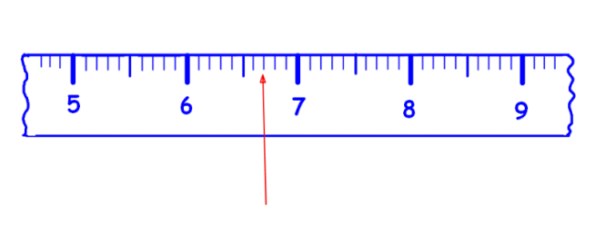
(b) | 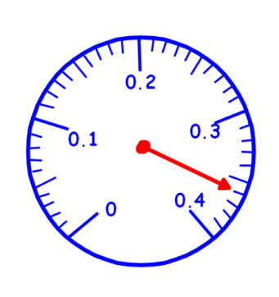

Add, subtract decimals up to 3dp
2. Copy and complete:
(a) 4.53 (b) 16.62 (c) 18.165
-
+
+
3.78 3.845 9.487

3. Calculate:
(a) 5.6 + 2.7 (b) 12.6 + 5.74 (c) 8.54 – 2.7 (d) 16.21 – 11.748

4. A 5 metre length of cable is cut into 3 strips.
The first strip is 3.42 m. The second strip is 0.75 m.
How long is the third strip?

5. (a) A 3.4 kg bag of salt is added to a 1.9 kg bag.
(i) What is the total weight?
(ii) What is the difference in weight?

(b) In a formula one race Neeson’s track times were 21.7 and 22.56 secs.
(i) What was the combined time?
(ii) What was the difference in the times?

Multiply, divide by 10, 100, 1000
6. Calculate:
(a) 8.4 x 10 (b) 0.91 x 100 (c) 4.021 x 100
(d) 18.71 x 10 (e) 5.213 x 1000 (f) 0.875 x 1000

7. Calculate:
(a) 28.6 ÷ 10 (b) 187.1 ÷ 10 (c) 64.1 ÷ 100
(d) 10.91 ÷ 100 (e) 521.3 ÷ 1000 (f) 0.8 ÷ 1000

8. The width of a car park space is 3.12 metres.
Calculate the width of: (a) 10 spaces (b) 100 spaces

Multiply, divide a decimal by a single digit whole number
9. Calculate
(a) 4.34 x 4 (b) 8.27 x 7 (c) 8.78 x 6
(d) 119.38 x 9 (e) 5.7 x 8 (f) 135.9 x 5

10. Calculate:
(a) 37.16 ÷ 2 (b) 91.44 ÷ 6 (c) 41.79 ÷ 7
(d) 129.12 ÷ 8 (e) 35.7 ÷ 7 (f) 0.072 ÷ 8

11. Shreek the ogre has eight worm lollies each 7.8 cm in length. What is the total length of all the lollies?

12. Marilyn bought eight concert tickets for £182. How much was it for each ticket?

Multiply and divide decimals by multiples of 10, 100, 1000
13. Calculate:
(a) 18 ÷ 30 (b) 42 ÷ 60 (c) 64 ÷ 80 (d) 540 ÷ 600
(e) 350 ÷ 500 (f) 630 ÷ 900 (g) 4·8 ÷ 3000 (h) 9·5 ÷ 5000

14. When 600 carpet tacks are weighed, their total weight is 138 grams.
What is the weight of 1 carpet tack?

Use a calculator to multiply and divide decimals
15. Mrs Binnie bought a silver chain for £265·90 and a necklace for £85·75.
One year later she sold the chain for £305 and the necklace for £102.
How much of a profit did she make altogether?

16. Madge sells printer cartridges, earning an annual salary of £13 837·20.
Calculate Madge’s weekly wage.

17. I returned with 50·05 euros from my holiday in Paris. How many £’s will I receive for them with the exchange rate at 1·54 euros to the £?

Multiply decimals together
18. Calculate:
(a) 0·8 x 0·6 (b) 0·08 x 0·6 (c) 0·008 x 0·6
(d) 0·0008 x 0·6 (e) (0·7)2 (f) 0·09 x 0·3
(g) 0·03 x 0·3 (h) 0·006 x 0·7 (i) 0·3 x 0·4 x 0·5
Block 1 Revision

Number Processes
MNU 3–03 I can use a variety of methods to solve number problems in familiar contexts, clearly communicating my processes and solutions
MTH 3-03b I can continue to recall number facts quickly and can use them accurately when making calculations
Core
1. Write 78 021 in words.
2. Write two million, four hundred thousand, five hundred in figures.
3. Calculate:- (a) 67209 + 4529 (b) 25 702 – 12 568
4. Calculate:- (a) 783 x 6 (b) 2934 ÷ 9
5. Calculate:- (a) 52 x 10 (b) 10 x 367 (c) 2020 x 1000
6. Calculate:- (a) 800 ÷ 10 (b) 300 ÷ 100 (c) 1 000 000 ÷ 1000
7. Calculate:- (a) 67 x 30 (b) 41 x 700 (c) 12 x 5000
8. Calculate:- (a) 45 000 ÷ 30 (b) 3600 ÷ 600 (c) 400000 ÷ 5000

Upper
9. Calculate:- (a) 56 x 45 (b) 782 x 38 (c) 6483 x 52
10. Calculate:- (a) 652 – 3 x 8 (b) 35 + 5 x 30 (c) 5 x (36 + 64)

Fractions and Percentages
MNU 3-07a I can solve problems by carrying out calculations with a wide range of fractions, decimal fractions and percentages using my answers to make comparisons and informed choices for real life situations
MNU 3-07b By applying my knowledge of equivalent fractions and common multiples, I can add and subtract commonly used fractions
MTH 3-07c Having used practical pictorial and written methods to develop my understanding, I can convert between whole or mixed numbers and fractions

Core
1. Write these as fractions in their simplest form:-
(a) 50% (b) 25% (c) 64% (d) 75%
(e) 20% (f) 66 2% (g) 33 1% (h) 12.5%
3 3
2. Change these fractions into percentages:-
(a) 7 (b) 2 (c) 1 (d) 17
10 5 3 20
(e) 24 (f) 20 (g) 225 (h) 3
40 30 1000 8

3. Calculate:-
(a) 1 of 66 (b) 3 of 48 (c) 8 of 27 (d) 5 of 616
3 4 9 7

4. Simplify each of the following fractions:-
(a) 7 (b) 3 (c) 14 (d) 11
14 12 42 88
(e) 12 (f) 6 (g) 25 (h) 27
78 84 625 126

5. Change to a mixed number: - (a) 22 (b) 83
7 3
6. Change to a top heavy fraction: - (a) 4 1 (b) 10 2
4 9
7. Calculate:-
(a) 10% of £56 (b) 20% of $800 (c) 50% of 602 kg
Upper
8. Calculate:-
(a) 20% of £75 (b) 65% of $840 (c) 12½ % of 808 kg

9. (a) 3 + 1 (b) 4 - 3 (c) 2 2 + 3 5 (d) 4 1 - 2 3
7 5 5 3 7 8 4 8
(e) 4 x 3 (f) 8 ÷ 3 (g) 5 4 x 1 2 (h) 6 2 ÷ 2 1
5 9 3 4 5 3 3 2

Decimals
MNU 3-07a I can solve problems by carrying out calculations with a wide range of fractions, decimal fractions and percentages using my answers to make comparisons and informed choices for real life situations
Core
1. Identify the numbers on the decimal scales.
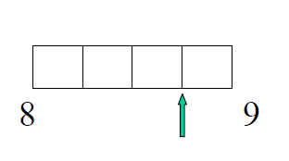

2. Calculate:- (a) 45.3 + 34.98 (b) 82.72 – 11.343
3. Calculate:- (a) 45.3 x 10 (b) 0.3445 x 100
4. Calculate:- (a) 67.3 ÷ 10 (b) 76.92 ÷ 100
5. Calculate:- (a) 67.45 x 5 (b) 1.62 ÷ 6

Upper
6. Calculate:- (a) 6.82 x 300 (b) 345.8 x 50
7. Calculate:- (a) 1.8 ÷ 60 (b) 42.7 ÷ 700
8. In a restaurant, a set menu costs £10.75 per person. How much would it cost for a meal for 28 people?
9. Calculate:- (a) 0.7 x 0.8 (b) 0.03 x 0.0021
10. Calculate:- (a) 0.36 ÷ 0.06 (b) 6.3 ÷ 0.7

Block 2

Ratio and Proportion

MNU 3–08a I can show how quantities that are related can be increased or decreased proportionally and apply this to problems in everyday contexts

Ratio
1. Write down each ratio in its simplest form:–
(a) 4 : 10 (b) 11 : 121 (c) 30 : 18 (d) 108 : 144
(e) 40 : 60 (f) ½ : 12 (g) 0·8 : 16 (h) 1·7 : 34.

2. The ratio of mice to rats in a factory is 4 : 5.
(a) How many mice are there if there are 60 rats?
(b) How many rats are there if there are 52 mice?

3. Den and Len share a £40000 lottery win in the ratio 3 : 5.
How much will each receive?

4. Share 1000 euros between Ali, Ben and Cari in the ratio 1 : 4 : 5.

Proportion
5. (a) Eight bottles of juice costs £4. How much would one bottle cost?
(b) Five DVD’s cost £80. How much would it cost for four DVD’s?
(c) If it takes 6 men 5 hours to build a wall, how long would it have taken 4 men?

6. Five identical videos can hold 800 minutes of playback.
How many minutes of playback could 4 videos hold?
Estimating and Rounding
MNU 3-01a I can round a number using an appropriate degree of accuracy, having taken into account the context of the problem.

Rounding to nearest 10, 100, 1000 etc

1. Round to the nearest 10:-
a) 71 b) 78 c) 129 d) 1995

2. Round to the nearest 100:-
a) 291 b) 78 c) 781 d) 23559

3. Round to the nearest 1000:-
a) 4500 b) 7299 c) 18901 d) 1 234 567

4. A fossil was discovered and was carbon dated at 127 891 years old. Round this figure
to the nearest:-
a) 10 b) 100 c) 1000 d) 100 000

Rounding to given number of significant figures

5. How many significant figures are there in each of these numbers :-
a) 62·0 b) 3·00 c) 1·009 d) 40·7
e) 26·30 f) 0·741 g) 0·027 h) 0·000 90 ?

6. Round each number to 1 significant figure :-
a) 53 b) 2679 c) 0·251 d) 0·000 815.

7. Round each number to 2 significant figures :-
a) 308 b) 5229 c) 48·55 d) 0·003 281.

8. Round each number to 3 significant figures :-
a) 9812 b) 72 091 c) 0·287 45 d) 0·019 999.

Finding an approximate answer

9) By rounding each number to 1 figure accuracy, find an approximate answer to each
of the following:-
a) 59 x 19 b) 379 x 320 c) 794 ÷ 38 d) 1961 ÷ 197

10) Nineteen houses in a street each use 311 litres of water every day.
Approximately how many litres of water is this every day?

11) The number of termites found in 196 mounds was 131 089.
Approximately, on average, how many would each mound have?

Negative Numbers
MNU 3-04a I can use my understanding of numbers less than zero to solve simple numbers in context
Core
- James had £60 in his bank account. He then withdrew £100. What will the balance be on his account now?

- The temperature in Moscow is -20ºC and the temperature in Glasgow is 10ºC. What is the difference in temperature?

- The temperature in Elgin was taken each day for one week. The results are shown below.
-3ºC, -2ºC, -4ºC, 0ºC, 1^{O}C, 3ºC, -2ºC
Calculate the average temperature for this week.

- Calculate:-
- 7 – 4 (b) 4 – 7 (c) 8 – 10 (d) 14 – 30
- -6 + 11 (f) -3 + 7 (g) -2 – 3 (h) -6 – 8
- 7 + (-3) (j) 4 + (-2) (k) 20 + (-10) (l) 18 – (-2)
(m) 20 – (-30) (n) 9 –(-20) (o) -80 – 10 (p) (-7) + (-6)

Upper
- Calculate:-
- 5 x (-4) (b) 6 x (-8) (c) (-7) x 8 (d) (-54) ÷ 9
(e) (-56) ÷ 8 (f) (-24) ÷ 8 (g) (4 x 8) ÷ 2 (h) (6 x 6) ÷ 4
(i) 10 x (4-8) (j) 6 x (7-14) (k) ((-3)-7) ÷ 2 (l) (-6) x (-9)
(m) (-45) x (-1) (n) (-48) ÷ (-4) (o) 3 x (-2) x 6 (p) ((-3)+(-15)) ÷(-3)
(q) (-3)² (r) (-2)³ (s) (-1) x (-1) x (-2) x (-2)

Block 2 Revision
Ratio and Proportion
MNU 3–08a I can show how quantities that are related can be increased or decreased proportionally and apply this to problems in everyday contexts
Core
1. Simplify the following ratios
a 4 : 20 b 3 : 27
c 7 : 84 d 12 : 108

2. The ratio of diesel to petrol is 4:7.
(a) How many petrol cars are there if there are:
(i) 8 diesels (ii) 20 diesels
(b) How many diesel cars are there if there are:
(i) 18 petrol (ii) 84 petrol

3. Show all your working for each of the following :–
(a) Share £1500 between Bill and Ben in the ratio 3 : 2.
(b) Share 360 sweets between May and Matt in the ratio 5 : 7.
(c) Share 1250 €’s between Tom and Tim in the ratio 7 : 3.
(d) Share ten thousand pounds between Dan and Fran in the ratio 23 : 27.

Upper
1. The cost of ten calculators is £50.
How much would it cost for:–
(a) one calculator (b) nine calculators ?

2. (a) 600 pencils cost £24. Find the cost of 400 pencils.
(b) A disc spins 3000 times in 8 minutes. How many times will it spin in 12 minutes?
(c) A computer makes three million calculations in 9 seconds. How many calculations will the computer make in 12 seconds?

Estimating and Rounding
MNU 3-01a I can round a number using an appropriate degree of accuracy, having taken into account the context of the problem
Core
1. Round the following numbers to the nearest 10
(a) 13 (b) 23 (c) 18

2. Round the following numbers to the nearest 100
(a) 140 (b) 260 (c) 180

3. Round the following numbers to the nearest 1000
(a) 2300 (b) 1978 (c) 4368

4. Round the following numbers to 1 decimal place
(a) 4.93 (b) 5.03 (c) 2.68

5. Round the following numbers to 2 decimal places
(a) 0.273 (b) 1.595 (c) 6.473

6. Estimate the following calculations
(a) 3.99 x 4.8 (b) 6.7 x 4.3 (c) 2.9 x 9.5

Upper
7. Round the following number to the stated number of significant figures
(a) 36.937 (3 sf) (b) 2.643 (2 sf)
(c) 19.6754 (4 sf) (d) 23139 (3 sf)
(e) 0.00348 (2 sf) (f) 0.04319 (2 sf)

8. For each calculation below :– (i) Round each number to one significant figure.
(ii) Give an approximate answer to each calculation.

(a) 199 x 19 (b) 3656 x 196 (c) 39 x 409
(d) 8705 ÷ 33 (e) 416 876 ÷ 3781 (f) 4489 ÷ 8091.

Negative Numbers
MNU 3-04a I can use my understanding of numbers less than zero to solve simple numbers in context
Core
1. James had £60 in his bank account. He then withdrew £100. What will the balance be on his account now?

2. The temperature in Moscow is -20˚C and the temperature and the temperature in Glasgow is 10˚C. What is the difference in temperature?

3. The temperature in Elgin was taken each day for one week. The results are shown below.
-3˚C, -2˚C, -4˚C, 0˚C, 1˚C, 3˚C, -2˚C
Calculate the average temperature for this week.

4. Calculate:-
(a) 7 – 4 (b) 4 – 7 (c) 8 – 10 (d) 14 – 30
(e) -6 + 11 (f) -3 + 7 (g) -2 – 3 (h) -6 – 8
(i) 7 + (-3) (j) 4 + (-2) (k) 20 + (-10) (l) 18 – (-2)
(m) 20 – (-30) (n) 9 – (-20) (o) -80 – 10 (p) (-7) + (-6)
(q) (-6) + (-18) (r) (-8) – (-8) (s) (-30) – (-10) (t) (-0.7) – 0.3

Upper
5. Calculate:-
(a) 5 x (-4) (b) 6 x (-8) (c) (-7) x 8 (d) (-54) ÷ 9
(e) (-56) ÷ 8 (f) (-24) ÷ 8 (g) (4 x 8) ÷ 2 (h) (6 x 6) ÷ 4
(i) 10 x (4 – 8) (j) 6 x (7 – 14) (k) ((-3) – 7) ÷ 2 (l) (-6) x (-9)
(m) (-45) x (-1) (n) (-48) ÷ (-4) (o) 3 x (-2) x 6 (p) ((-3) + (-15)) ÷ (-3)
(q) (-3)² (r) (-2)³ (s) (-1) x (-1) x (-2) x (-2)

Block 3
Angles
MTH 3–17a I can name angles and find their sizes using my knowledge of the properties of a range of 2D shapes and the angles properties associated with intersecting and parallel lines

MTH 2-17b I can accurately measure and draw angles using appropriate equipment applying my skills to problems in context

Measure and draw angles using a protractor
1. Name and write down the size of each angle below:
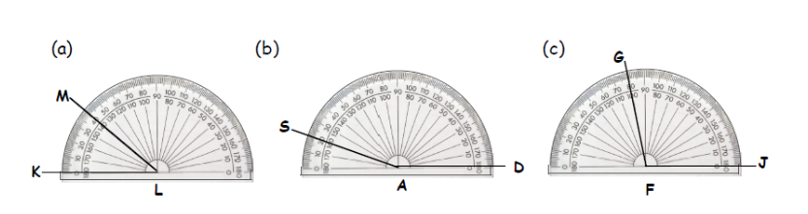
2. Draw and label the following angles.
(a) 45° (b) 78° (c) 115° (d) 172°.
Explain different types of angles
3. Make a sketch to show examples of:
(a) a right angle (b) an acute angle (c) an obtuse angle
(d) a straight angle (e) a reflex angle.
4. (a) Copy and complete : A straight angle is exactly ....º.
(b) Describe the following angles:-
(i) right (ii) acute (iii) obtuse (iv) reflex.
5. Write the type of angle of each of the following:
(a) 47º (b) 91º (c) 176º (d) 180º
(e) 190º (f) 1º (g) 90º (h) 270º

Show how to name an angle
6. Use 3 letters to name each of the angles marked:
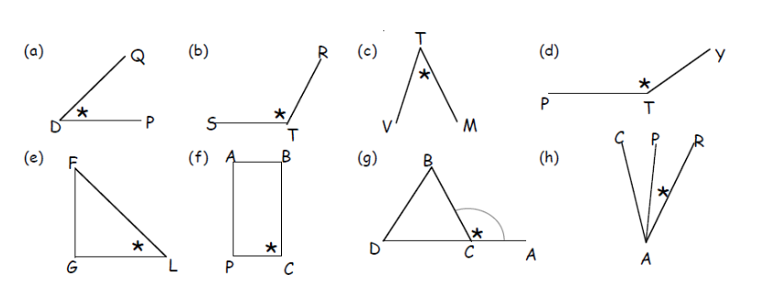

Calculate missing angles using knowledge of corresponding alternate angles and vertically opposite angles
7. Make a neat rough sketch of each of the following diagrams. Fill in all the missing angles.
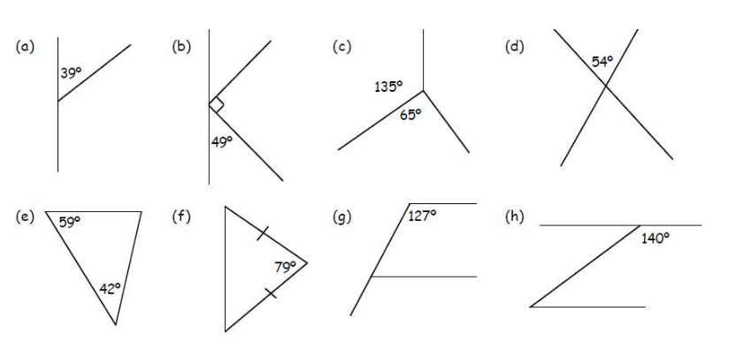

Extend to more complex questions and problems show how to identify compass directions and give as 3 figure bearings
8. Sketch each of the following and fill in all the missing angles:
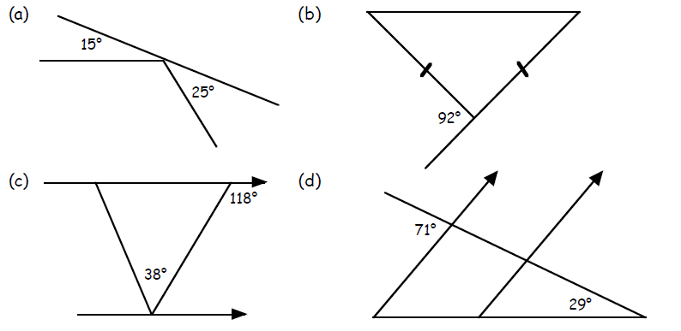
9. How many degrees are there from:
(a) South West to North (clockwise) (b) East to North East (clockwise)

10. Write down the three figure bearing of:
(a) South east (b) West

11. (a) Bill was facing South East. He made a quarter turn anti-clockwise.
In which direction is he now facing?
(b) Jane was walking North West and turned 180º.
In which direction is Jane now walking?
(c) An aeroplane is flying North East. The pilot turns 135º anti-clockwise.
In which direction is the plane now flying?

Scale Drawing
MTH 3 – 17b Having investigated navigation in the world, I can apply my understanding of bearings and scale to interpret maps and plans and create accurate plans, and scale drawings of routes and journeys.
MTH 3-17c I can apply my understanding of scale when enlarging or reducing pictures and shapes, using different methods, including technology.
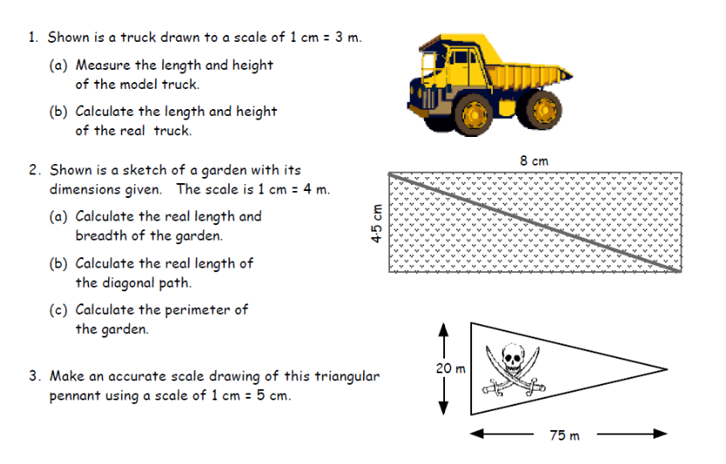
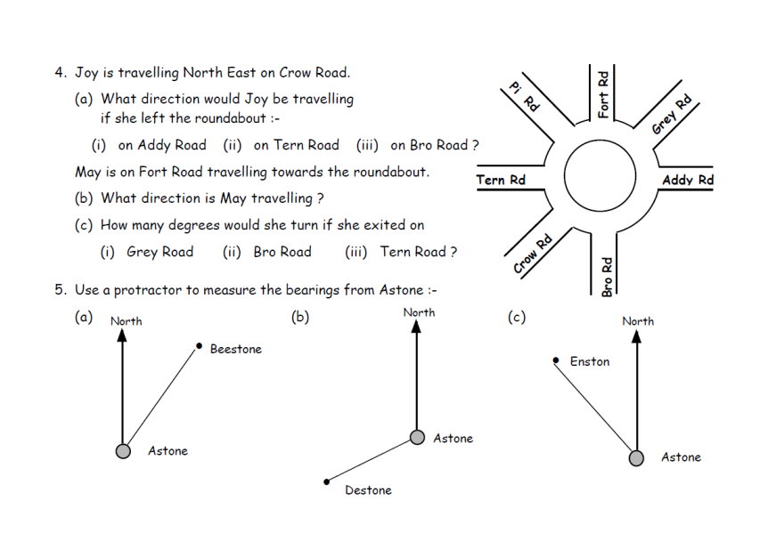

Coordinates
MTH3 – 18a I can use my knowledge of the co-ordinate system to plot and describe the location of a point on the grid
MTH 4 – 18a I can plot and describe the position of a point on a 4 quadrant coordinate grid

Read, use and plot coordinates in the first quadrant
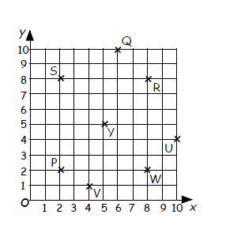
1. (a) Which point has coordinates:-
(i) (4, 1) (ii) (10, 4)
(iii) (2, 8) (iv) (5, 5)?
(b) Write down the coordinates of:-
(i) Q (ii) R
(iii) P (iv) W.
(c) When four of the points are joined
a square is formed.
(i) Which four points?
(ii) Write down their coordinates.

2. (a) Draw up a coordinate grid like the one in question 1 on squared paper,
make the horizontal and vertical axes both go up from 0 to 10.
(b) Mark with a small neat cross the position of the following points:-
A(1, 1), B(9, 1), C(9, 6), D(5, 10), E(1, 6).
(c) Join point A to point B; point B to point C; point C to point D; point D to
point E, point E back to point A.
(d) What shape have you formed?

Read, use and plot coordinates in four quadrants
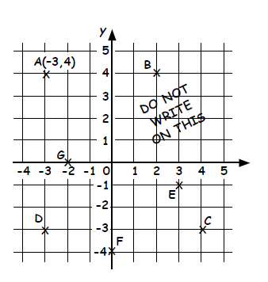
3. The coordinates of A are (–3,4).
(a) Write the coordinates of the other points.
(b) Which point has an x-coordinate of 2?
(c) Which point has a y-coordinate of -3?
(d) What is the x-coordinate of D?
(e) What is the y-coordinate of F?
(f) Which point has its x-coordinate
the same as its y-coordinate ?
(g) Which point lies on the x-axis?
(h) Which point lies on the y-axis?

4. (a) Copy the set of axes from question 4.
(b) Plot the following five points: - J(2, 3), K(–1, 5), L(–4, 3), M(–4, –1) and N(2, –1).
(c) Name the shape formed when the five points are joined up in order.

5. (a) Draw a set of axes from –5 to 5 on both axes.
(b) Plot the points S(3, 2), T(5, 2) and U(6, 5).
(c) Join the three points and write the name of the shape formed.
(d) Reflect this shape over the x-axis.
(e) Write the coordinates of the vertices of the new shape found.
Symmetry
MTH3.19-a I can illustrate the lines of symmetry for a range of 2D shapes and apply my understanding to create and complete symmetrical pictures and patterns

Draw lines of symmetry
1. Write down how many lines of symmetry each of these shapes has.
(a) (b) (c)

Create and complete symmetrical pictures and patterns
2. Copy each of the following shapes neatly, and complete each one such that the dotted line is a line of symmetry.
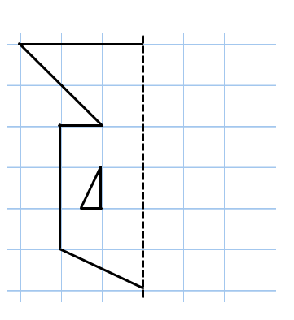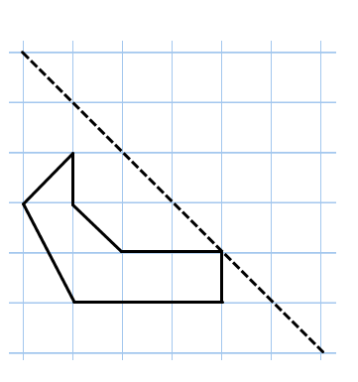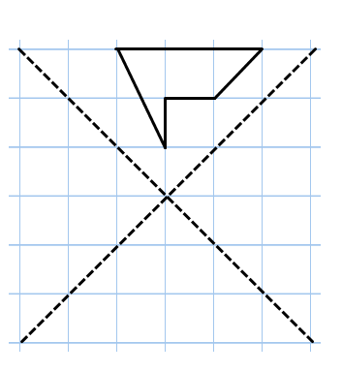

Recognise rotational symmetry
3. Which, if any, of these shapes has half-turn symmetry?
(a) (b) (c)

4. For each shape in question 1, state the order of symmetry each time.

Create a shape/picture with rotational symmetry
5. Copy each shape and give each a half turn around the dot.
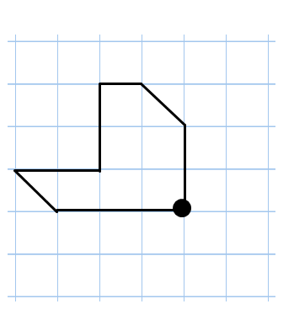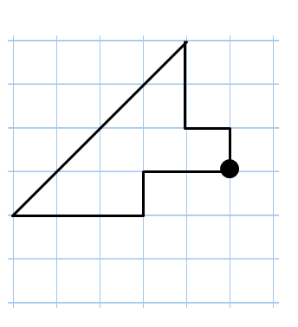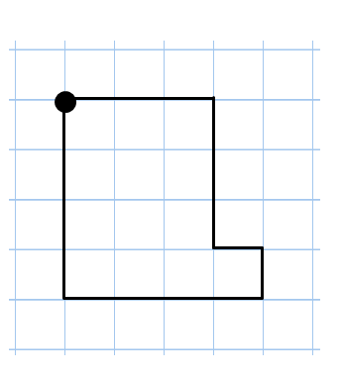

2D Shape

MTH 3–16a Having investigated a range of methods, I can accurately draw 2D shapes using appropriate mathematical instruments.
MTH 3-17b I can name angles and find their sizes using my knowledge of the properties of a range of 2D shapes and the angle properties associated with intersecting and parallel lines.

Quadrilaterals
1. Copy and complete:-
“The four angles of a quadrilateral always add up to ……..”

2. Explain why a rhombus is different to a square.

3. Write down 2 properties of a parallelogram which makes it different from a rectangle.

4. Write down the one property every trapezium has.

Circle
5. Draw a circle with a diameter and a radius. Label all parts of your diagram.

6. Write the length of the diameter for a radius of length:-
(a) 3 cm (b) 7 cm (c) 52 m (d) 8·5 km

7. Write the length of the radius for a diameter length of:-
(a) 12 cm (b) 56 cm (c) 1 m (d) 6·5 km

Drawing Triangles
8. Make accurate drawings of the following triangles.
(a) ΔABC where AB = 10 cm, BC = 6 cm and ∠ABC = 70°.
(b) ΔPQR where PQ = 9 cm, ∠PQR = 50° and ∠QPR = 40º.
(c) ΔSTY where ST = 8 cm, ∠STY = 10° and ∠TSY = 150º.
(d) ΔJKL where JK = 11 cm, JL = 14 cm and KL = 2 cm.

Interior and Exterior Angles
9. How many sides has a regular:-
(a) pentagon (b) heptagon (c) nonagon

10. Calculate the size of the interior angles of a regular:-
(a) hexagon (b) octagon (c) decagon.

11. Calculate the size of the exterior angles of a regular:-
(a) pentagon (b) duodecagon (12 sides) (c) 20 sided polygon.

12. (a) An interior angle of a regular polygon is found to be 108°.
What is the regular polygon called?
(b) An exterior angle of a regular polygon is found to be 120°.
What is the regular polygon called ?

Block 3 Revision
Angles
MTH 3–17a I can name angles and find their sizes using my knowledge of the properties of a range of 2D shapes and the angles properties associated with intersecting and parallel lines
MTH 2-17b I can accurately measure and draw angles using appropriate equipment applying my skills to problems in context

Core
1. Draw and label the following angles.
(a) 55° (b) 28° (c) 155° (d) 168°.
1. Write the type and name of each angle shown :-
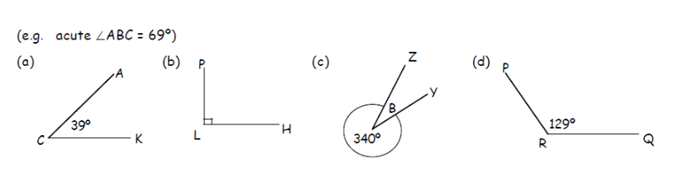
2. Calculate the unknown angles :-
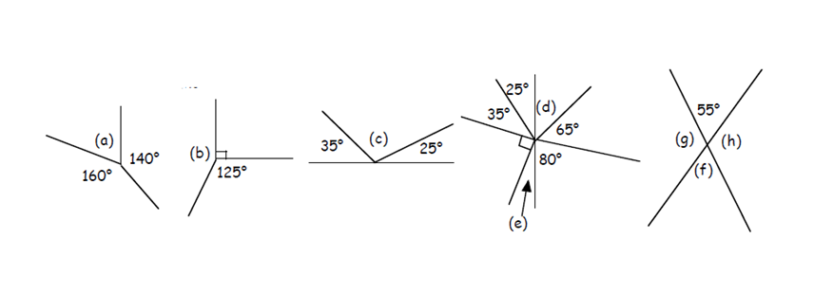

Scale Drawing
MTH 3 – 17b Having investigated navigation in the world, I can apply my understanding of bearings and scale to interpret maps and plans and create accurate plans, and scale drawings of routes and journeys.
MTH 3-17c I can apply my understanding of scale when enlarging or reducing pictures and shapes, using different methods, including technology.
Core
1.
2. | 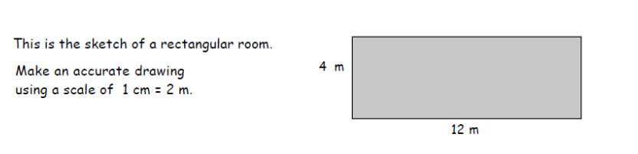
3. | 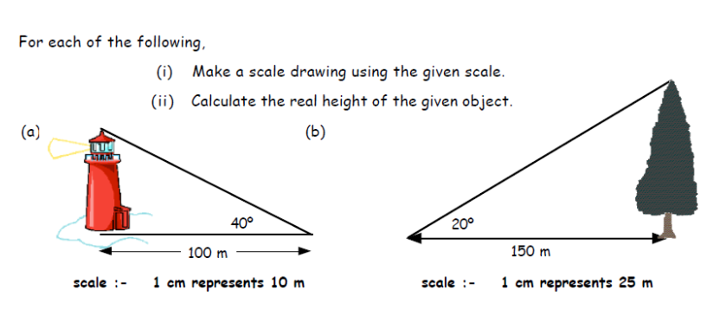
4. | 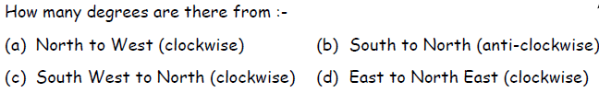

Upper
1. | 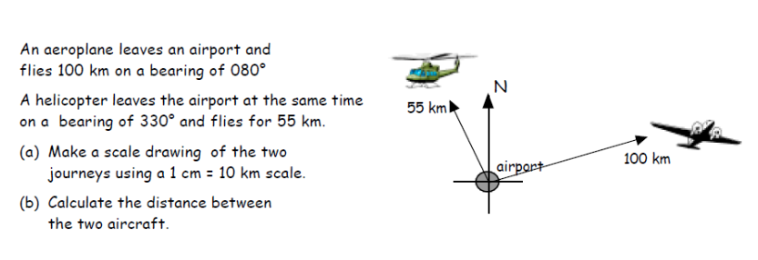
2. | 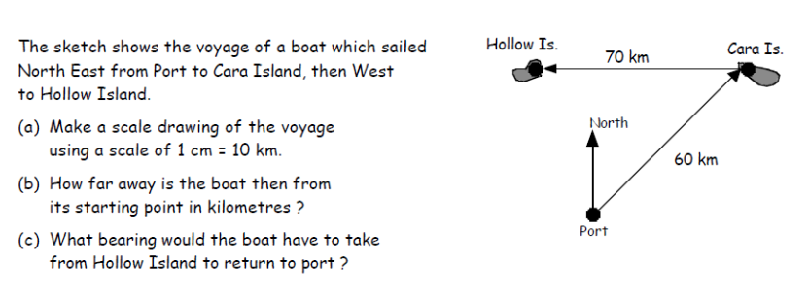
3. | 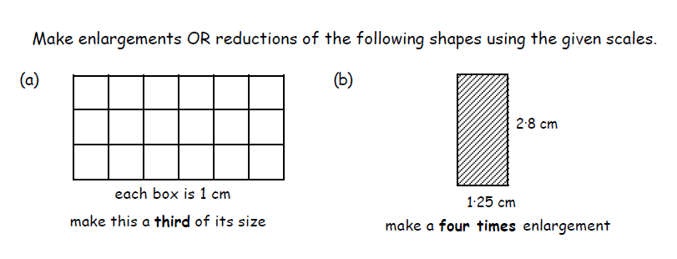
4. | 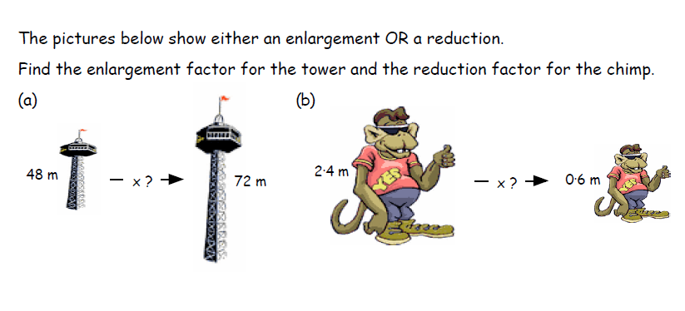

Coordinates
MTH 3 – 18a I can use my knowledge of the co-ordinate system to plot and describe the location of a point on the grid
MTH 4 – 18a I can plot and describe the position of a point on a 4 quadrant coordinate grid
Core
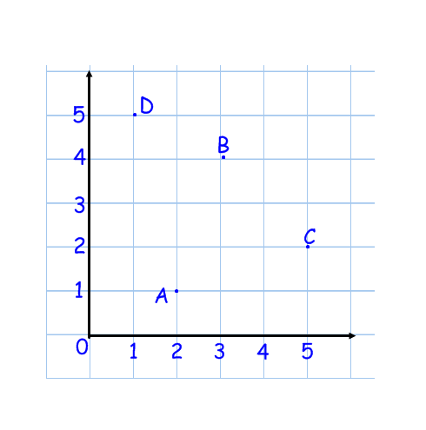
1. Four points are shown in the coordinate grid.
Write down the coordinates of A, B, C and D.

2. (a) Draw a grid with an x-axis of 5 and a y-is of 8.
(b) Plot the points P(4,2), Q(3,8) and R(2,6).

Upper
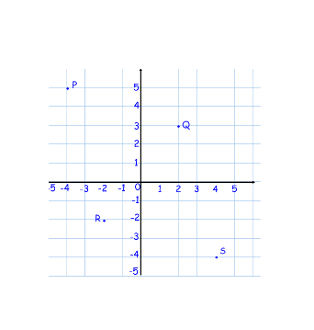
3. Four points are shown in the coordinate grid.
Write down the coordinates of P, Q, R and S.

Symmetry
MTH3.19-a I can illustrate the lines of symmetry for a range of 2D shapes and apply my understanding to create and complete symmetrical pictures and patterns
Core
1. Write down how many lines of symmetry each of these shapes has.
2. Copy each of the following shapes neatly, and complete each one such that the dotted line is a line of symmetry.
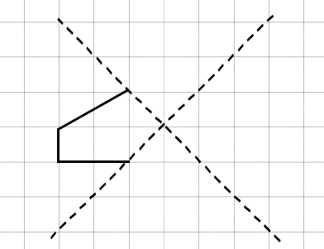
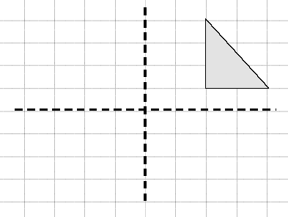

Upper
3. State the order of symmetry for each shape.
4. Copy and complete the shape so that it has half-turn symmetry about it’s centre.
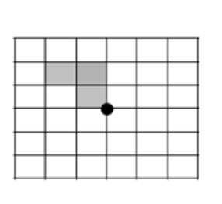

2D Shape
MTH 3–16a Having investigated a range of methods, I can accurately draw 2D shapes using appropriate mathematical instruments.
MTH 3-17b I can name angles and find their sizes using my knowledge of the properties of a range of 2D shapes and the angle properties associated with intersecting and parallel lines.
Core
1. I have 2 pairs of parallel lines, 2 pairs of lengths that are equal, 4 right angles and 2 lines of symmetry. What is my shape?

2. Copy out the shapes and fill in as many angles.

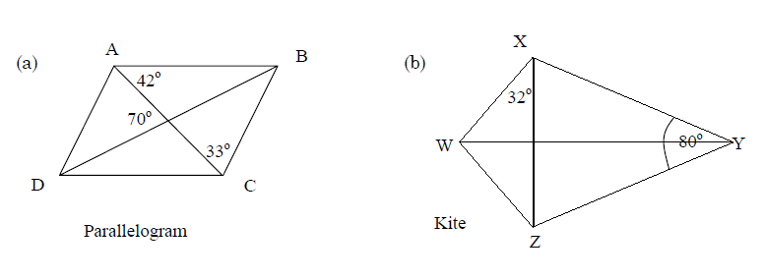
3. Name the given parts of the circle.
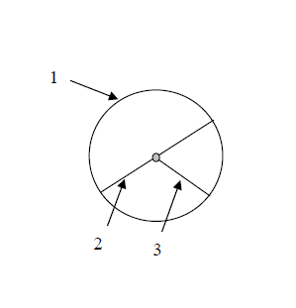
4. Write down the diameter of a circle if the radius is 7cm.

5. Write down the radius of a circle if the diameter is 6cm.

6. Make an accurate drawing of triangle MNP when:
MN = 7.8 cm
MP = 9 cm
Angle NMP = 77º

7. Copy the triangle and surround it with eight congruent tiles to show that it will “tile the plane”.
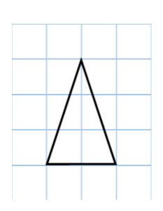
Upper
1. What is the name of a regular polygon which has:-
(a) 5 sides (b) 6 sides (c) 7 sides
(d) 8 sides (e) 9 sides (f) 10 sides
2. Find the size of the interior angles of a regular:-
(a) pentagon (b) nonagon (c) 20 sided polygon.
3. Calculate the size of the exterior angle of :-
(a) a regular pentagon (b) a regular nonagon.

