Calling all cooks - Template
This is style of template to use to type up your recipes.

Recipe Name: | My recipe name
Ingredients:  (List your ingredients and measurements) | - Ingredient 1  - Ingredient 2  - Ingredient 3  - etc
Method:  (List the steps you took and what you did in order) | - Step 1  - Step 2  - Step 3  - Step 4
Cooks Name | Mr, Mrs, Miss etc
Picture (optional) | 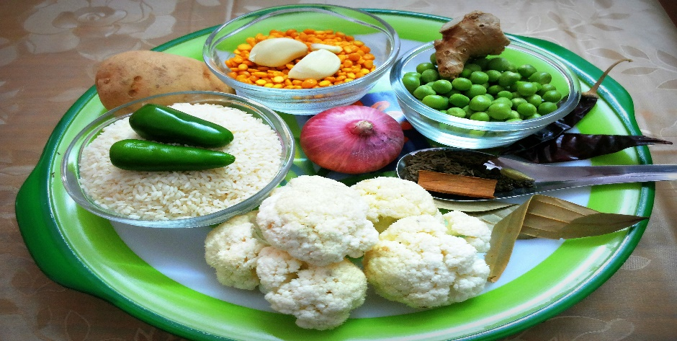  This Photo by Unknown Author is licensed under CC BY-SA-NC

Email recipes to gordonschools.aca@aberdeenshire.gov.uk

