IMPORTANT INFORMATION

If you are planning to apply for University in session 2021/22 you need to register with UCAS.
UCAS.COM
UCAS is a very informative and easy to navigate website and we would strongly recommend you spend time becoming familiar with it.
It is vitally important that you are investigating your chosen university courses and looking at specific entry requirements and application deadlines.
A few courses have early deadlines in October such as: -

Medicine, dentistry, veterinary medicine or veterinary science

or Applications to

The University of Oxford or The University of Cambridge
There is detailed information on the UCAS website regarding applications to the above. If this does affect you, please get in touch with your guidance teacher ASAP to make them aware of your plans.

Your guidance teachers would normally be working through the registration process with you.
We are not in school but it essential that you go ahead and register with as much information as possible before the summer holidays.

There are two tasks that we would like you to complete.

- Register with UCAS (details follow)

- Complete the pupil reference form (at the end of the document). By 26th June 2020

This will allow your Guidance Teacher to start to think about the reference they will submit as part of your UCAS application.

Below are the different stages involved in making an application.

Some can be done now, and some are best left until after the summer.

- Register to use Apply – Please complete this

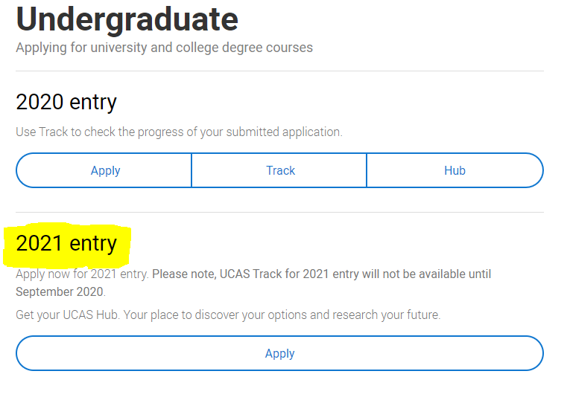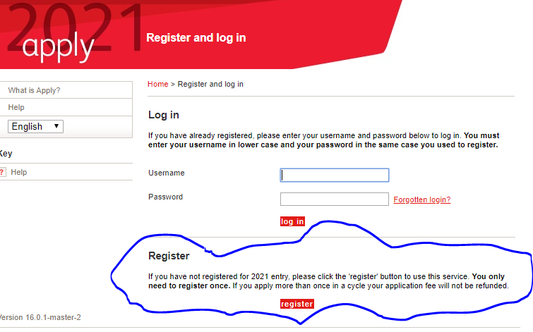

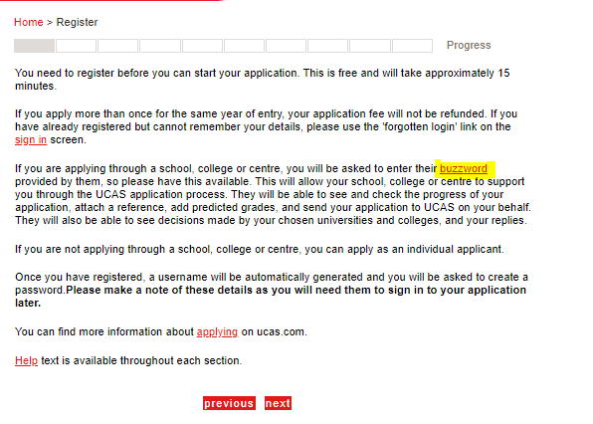

You will be prompted for a buzzword.

This is:
TGS2020

Sign in to fill in the rest of your personal details – Complete This

3. Additional info (UK applicants only) – Complete This

4. Student finance (UK and EU applicants only) Complete This

This is a section on who will pay your fees. This is SAAS and you will find it in the drop-down list.

5. Course choices - No need to complete now unless you are certain of your choices.

6. Full education history – You can fill in what National qualifications you achieved.

7. Your employment history – If you have had or have a job you can fill this in.

8. Write a personal statement - Please read and watch all the advice and information given on this on the website. It would be great for you to start drafting this before we return to school.

9. View all the details – Not needed now.

10. Then get a reference, pay your application fee and send your application – Not needed now.

Pupil Reference Form
Name:
Please complete and Send to your Guidance Teacher by 26th June 2020.
- What courses/area of study are you considering?

- Qualifications to date:

- Pending Qualifications

- Details of employment/Work Experience

- Details of Volunteering Opportunities

- Positions of responsibility in school

- Membership of clubs/organisations

- Achievements to date

- Future Aspiration

