[](https://bbox.blackbaudhosting.com/webforms/linkredirect?url=https://www.mentalhealth.org.uk&srcid=21973069&srctid=1&erid=1509594709&trid=8244a82f-9cd0-4c12-8a46-4aaea1d923f7&linkid=224167638&isbbox=1)

Marr ‘Transition Back to School Quick Bite’

**Supporting Children, Young People, Parents and their**

**Families back into Education**

Children and young people going back to school after lockdown is going to be a big change for everyone. The ongoing impact of COVID19 on all our lives will require both recovery and readjustment. Whilst everyone will have been through a shared experience, we will all have experienced it differently. Having been together at home for a long time means that family routines will have changed quite a lot.

As we begin to make the return to school/education we will need to think carefully about how to support all children and young people to do this. Some individuals will benefit from more support than others and may require longer to make the readjustment. We are also, not necessarily returning to the school as we previously knew it. There have been changes to physical spaces, social expectations and for some there has been an impact on their individual well-being. It is important to highlight that for some individuals there will have been losses and significant change.

You will find some helpful resources listed below from [**Aberdeenshire Council Educational Psychology Team**](https://www.aberdeenshire.gov.uk/schools/eps/), the [**NHS Grampian CAMHS Service**](https://www.camhsgrampian.org/) (Children & Adolescent Mental Health Services and the Mental Health Foundation).



**The Aberdeenshire Educational Psychology Team has developed a website which is packed with helpful resources and tips for schools, young people and parents.**[**https://blogs.glowscotland.org.uk/as/aberdeenshireeps/returning-to-school/**](https://blogs.glowscotland.org.uk/as/aberdeenshireeps/returning-to-school/)

This resource from **Place2Be** is more suitable for teachers and provides many great ideas for assembly or classroom discussions and activities for all children returning to school. The resource is split into four categories: self-efficacy, hope, gratitude and connectedness.

[Primary school resource](https://www.place2be.org.uk/media/yesltwzt/primaryschoolresources.pdf)

[Secondary school resource](https://www.place2be.org.uk/media/uvzkzysp/secondary-school-return-to-school.pdf)

This resource from **NHS Grampian** provides many practical ideas for preparing your child for their return to school.  This resource is most suitable for parents and carers.  It provides tips and advice about preparing and planning with your child for their first day back though, as well as, activities that can be put in place now and over the coming weeks – for instance the use of movement breaks or how to prepare your child from the reduction of learning via a screen.

[NHS – Helping your child back to school after lockdown](https://www.canva.com/design/DAEDXEEHAKI/Au7mxg2S-rUOt-X-_0R8Wg/view?utm_content=DAEDXEEHAKI&utm_campaign=designshare&utm_medium=link&utm_source=publishsharelink)

Please access the following pages for more specific support:

[For bereavement support click here.](https://blogs.glowscotland.org.uk/as/aberdeenshireeps/bereavement-support/)

[For wellbeing resources and information please click here](https://blogs.glowscotland.org.uk/as/aberdeenshireeps/wellbeing-resources/)

[For ASN resource click here](https://blogs.glowscotland.org.uk/as/aberdeenshireeps/autism-and-learning-difficulties/)

[For autism support click here](https://blogs.glowscotland.org.uk/as/aberdeenshireeps/autism-support/)

[For transition resources click here](https://blogs.glowscotland.org.uk/as/aberdeenshireeps/transition/)

[For returning to school worries parental leaflet click here](https://blogs.glowscotland.org.uk/as/public/aberdeenshireeps/uploads/sites/2304/2020/07/01154106/Returning-to-school-worries-parental-leaflet.pdf)

**Teachers**

As a teacher, you are likely to be already aware of the experiences that your pupils are having, and as schools reopen, the specific challenges that your school community is facing will become clearer.

Supporting your pupils through this transition will draw on many of the skills you use day-to-day to provide emotional and academic advice and guidance.

Things to keep in mind

• **One size will not fit all** – different pupils within the same class will have had very different experiences of the lockdown period. They will also have varying levels of coping skills and resilience in dealing with those experiences. Having an open mind about what pupils may be going through and how they will be coping with it will be important.

• **You are part of a team** – some of the challenges facing you as a teacher may feel overwhelming, but other teachers in your school, community and around the world are facing the same issues. Observing appropriate limits around pupil confidentiality, draw on other teachers and school leaders for support and guidance. Share what you are learning with them.



Returning to school after the coronavirus may be making you feel worried. That's why our Early Intervention Team have created resources for children, teens and parents.

Click on a button below to access our PDF packs!

[**https://www.camhsgrampian.org/back-to-school**](https://www.camhsgrampian.org/back-to-school)

[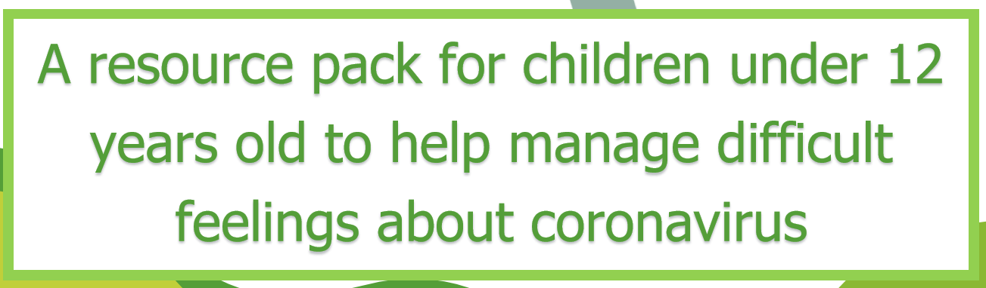](https://covid19.nhsgrampian.org/wp-content/uploads/2020/04/COVID-19-Resource-Pack-Unders-Its-ok-to-worry-about-coronavirus.pdf)[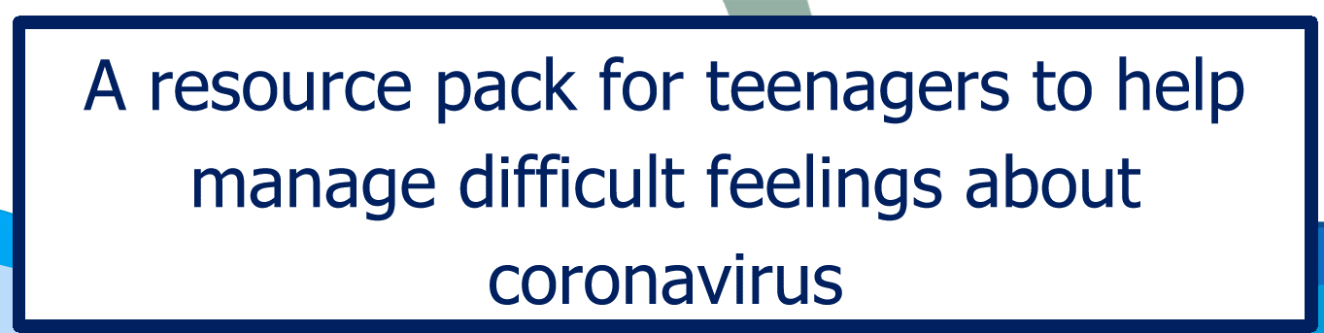](https://covid19.nhsgrampian.org/wp-content/uploads/2020/04/COVID-19-Resource-pack-overs-its-ok-to-worry-about-coronavirus.pdf)



Returning to school after the coronavirus lockdown

[**Challenges facing schools and pupils**](https://www.mentalhealth.org.uk/coronavirus/returning-school-after-lockdown/challenge-facing-schools-pupils)

[**How to support pupils returning to school**](https://www.mentalhealth.org.uk/coronavirus/returning-school-after-lockdown/support-pupils-return-to-school)

[**Tips for parents and caregivers**](https://www.mentalhealth.org.uk/coronavirus/returning-school-after-lockdown/tips-parents-carers-return-to-school)

[**Tips for school leaders**](https://www.mentalhealth.org.uk/coronavirus/returning-school-after-lockdown/tips-school-leaders-return-to-school)

[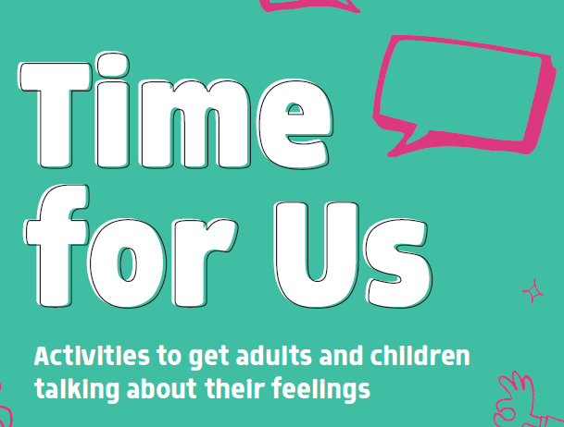](https://www.mentalhealth.org.uk/sites/default/files/MHF-Scotland-Parents-Pack.pdf)

[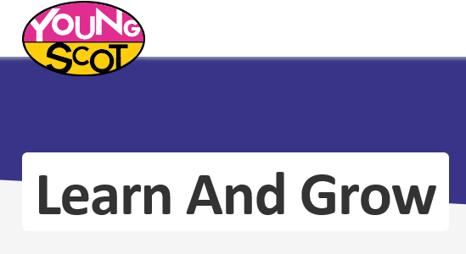](https://young.scot/learn-and-grow)

Useful information for our young adults

[](https://young.scot/aberdeenshire)



Discover games, videos and more on topics important to you

and your child

[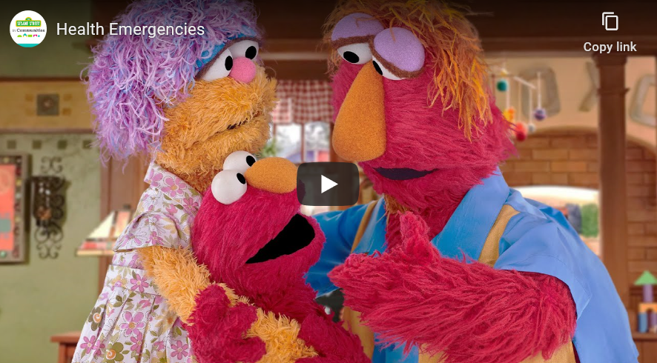](https://sesamestreetincommunities.org/topics/health-emergencies/)

Sing along with the friends of mindful music

[](https://www.mindfulmusic.london/resources)[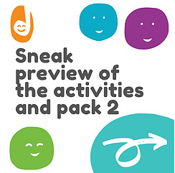](https://youtu.be/y6jkqQS9tcU)

