Warning and Information - Contact Tracing Telephone Scam

Following a report of a suspected Contact and Trace Telephone Scam in the Forth Valley Area yesterday. I hope the below information will be useful. Please feel free to forward this information to family, friends, neighbours and any social media groups you may be part of. One simple conversation may stop someone becoming a victim to these criminals.
Throughout the Covid-19 pandemic, scammers have been keeping up to date with the latest developments. Now, with the launch of NHS Scotland’s Test and Protect service and the new Protect Scotland contact tracing app, consumers are being warned to be wary of fraudsters posing as contact tracers.There have been reports from Scottish consumers about cold callers who say that you have been in contact with someone who has tested positive for Covid-19 and ask you to pay £500 to take a test.
Genuine contact tracers may first send you a text to let you know that you will receive a call from NHS Scotland. Calls will be made from 0800 030 8012.
Callers will:
- Introduce themselves and state the reason for their call
- Address you by your name
- Ask for details of people you have come into contact with, in a relevant time period
- Inform you that you will receive further information by email with advice on isolation and the support available (if you don’t have access to email, they may ask for your home address so this information can be delivered to you by post)
They will NOT:
- Ask you for information other than your movements and the people you have been in contact with
- Ask for financial information such as bank or credit card details
- Ask for details of medical records
- Try to sell you anything or ask for any payments or donations
- Ask you to set up a PIN or download anything
- Ask for your social media details, passwords or PIN numbers
- Ask for remote access to your computer
- Ask you to phone a premium rate number or visit a website other than NHS Scotland or the Scottish Government
Genuine contact tracers will give you the option to call the above national number to verify that the service is genuine.
Get information about contact tracing in Scotland from official sources: NHS Scotland, the Scottish Government or Public Health Scotland.
Report contact tracing scams to Advice Direct Scotland. If you have been the victim of a fraud, report it to Police Scotland on 101.
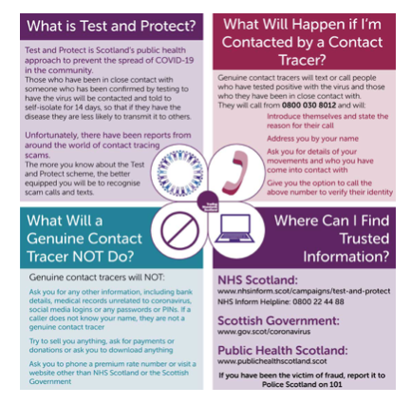
Message Sent By
Mark Armstrong (NHWN, Community Support Officer, NW Scotland)
To reply or forward this email please use the buttons below or these links: Reply, Rate, Forward / Share.

