Together Growing Succeeding

The Gordon Schools Newsletter 6
Session 2020-21

21st February 2021

Hello to all our Parents & Carers, Families and Pupils,

It’s been a very busy few days since the announcement that a very limited number of pupils will be able to return to support selected practical learning and teaching this coming week. All pupils and families who are due in have already been contacted by e-mail, and this will be in place for the next three weeks. We await further information and guidance from Scottish Government and NHS as to whether any further extension of this will be allowed for the final three weeks of this term.

For all other Senior Phase subjects and pupils, as well as our S1, S2 and S3 pupils, we continue with our on-line learning. Our offer will have to be balanced against the need for some teachers to devote time in School to their Senior Phase practical pupils. Therefore, during this initial three week timetable, there will not be the same availability for on-line learning in Technical subjects, Home Economics, Music, Drama, Art, Modern Languages and ICT & Business subjects.

There is more detailed information below around the specific in-School arrangements that will be in place from Monday as well as the new Covid19 testing offer and other TGS related matters.

Information for you:

- Selected practical subjects’ arrangements 22 February – 12 March
- COVID-19 asymptomatic testing programme
- Engagement with learning
- NESCol Link Courses
- Course choice and personalisation process for current S2, S3, S4 and S5
- Support from Skills Development Scotland for families and next steps
- Free school meals entitlement
- SQA update
- Parents in Partnership (PiP)
- Calendar dates and changes for this 20-21 session
- P7 transition 21-22
- TGS news
- Help with your Wellbeing Concerns
- Active Schools & Aberdeen Football Community Trust resources
- Scottish Apprenticeship week
- Contacting TGS & Accessing Aberdeenshire Council Services

Selected practical subjects’ arrangements 22 February – 12 March
From tomorrow we welcome back small groups of our SQA Senior Phase learners in some of their practical subjects. TGS is capped at a maximum of 52 pupils in any one day for this purpose. We are continuing to offer support with on-line learning for Keyworker and other identified pupils during this time. To accommodate both groups of pupils in the building simultaneously, we have adjusted our School day.
See below:

When pupils are in TGS for timetabled SQA classes, they will spend the whole day in that one subject. Classes will be at a maximum size of 10 pupils. School transport will be the usual pick-up points and times, but pupils must wear masks and socially distance on the buses. Similarly, when in TGS pupils must wear masks unless eating/drinking in our Canteen and must socially distance from one another as well as from all adults in the building. We would strongly encourage all pupils to either use our Canteen at Interval and Lunch or to bring in a packed lunch due to the shortened lunch break. Anyone in Huntly shops must follow their guidelines.

The one-way system will be in operation during period changes and intervals/lunch. SQA pupils should enter and exit TGS only at our Front Reception. Other pupils should enter and exit via the Bus Park corridor.

Pupils must only attend on the days they have been invited in for.

COVID-19 asymptomatic testing programme
The asymptomatic testing programme is currently available to all secondary school staff and all senior phase pupils in Scotland. It is available to begin with for all who are regularly attending in the School building and will be further rolled-out as and when more senior pupils are permitted to return.

Its purpose is to contribute to the reduction of COVID-19-related risks in schools, and in so doing to enhance the confidence of our school communities. It will do this by helping to identify asymptomatic individuals in school environments at the earliest possible opportunity and asking them and their close contacts to self-isolate, thus minimising the likelihood of them passing on the virus.

This programme is voluntary – nobody should be required to undergo testing without consent, and nobody should be excluded from school if they do not wish to test. However, we are asking that school staff and senior phase pupils be strongly encouraged to participate, in order to contribute to the wellbeing of their school communities.

N.B. This regular testing is only for individuals without symptoms. Those with symptoms must continue to follow national guidance. They must self-isolate and book a PCR test at a test centre or via a home test kit at the earliest opportunity. People with symptoms must not rely on a negative LFD result to continue to attend school.

Engagement with learning
It is vitally important that anyone who is having difficulties with content, deadlines or understanding what is being asked, contacts their teacher (via TGS if you need) to request support and clarification. Please remember to check for learning activities on your Teams’ pages as well as the Assignment tabs. Be careful when submitting Assignments that you include an attachment. When teachers are concerned about engagement, it often results from blank / empty submissions to Assignments.

If, during the course of on-line learning, your child has an issue or problem and is nervous or unsure how to address it, please see the ‘Confidential Help Form’ below that can be submitted:

https://forms.office.com/Pages/ResponsePage.aspx?id=oyzTzM4Wj0KVQTctawUZKQy78BQAHkBEsQ7X0bh9CfhUOTFLVjNMQ0swS0xQOENPMkpZQldZR1pQMy4u

Resources:
Aberdeenshire Council have a site that parents / carers can access with support and resources for remote learning.
The website link is: http://bit.ly/ShireDigitalSupport
If this doesn’t work, try this one below:
https://sites.google.com/as.glow.scot/digitaladviceparents/home

The site can be easily accessed on any device, including smartphones.

NESCol Link Courses
Pupils who are enrolled in our NESCol Link courses should be accessing their learning via the ‘Blackboard’. Please ensure that you are logging on weekly to check for and submit any tasks/assignments that are due in. Even if there are no scheduled on-line or live classes, there is still likely to be tasks posted for you to complete and submit. If you are having any issues with this, contact your on-line Tutor in the first case and if these are not resolved, please let Miss Raeside know and she will support with this.

Course choice and personalisation process for current S2, S3, S4 and S5
Families will receive information this coming week on our processes. This will be a two-stage process, firstly using an on-line form and then later via an on-line platform called TOOLS. If you are unable to access these, then we will make alternative arrangements for you – please let us know if this is the case.

There will be separate support materials on our website for S2’s moving into S3; S3’s going into S4 and S4/5’s transitioning into S5 and S6. You will receive more information on this shortly.

Support from Skills Development Scotland for families and next steps
Lisa OBrien SDS Careers Adviser will be continuing to contact pupils at home. Please feel free to contact Lisa via email Lisa.obrien@sds.co.uk

There is a wealth of information available on www.myworldofwork.co.uk. Other related websites: www.mykidscareer.com
www.Skillsdevelopmentscotland.co.uk www.apprenticeships,scot

Free school meals entitlement
For those families who currently have eligibility to Free School Meals, the next payment is due to be made into the parents nominated bank accounts on Monday 22nd February. This will cover the 3 week period from 22nd February to
14th March. Each child will receive £52.50 for this period (£17.50 per week).

Will I qualify for Free School Meals / School Clothing Grant and how do I apply?

Please use you the following link to make an application for the above. This application process will advise you if you meet the eligibility criteria: Apply here A school clothing grant is currently £100 per eligible child, per year. More information about Free School Meals and School Clothing Grants can be found here.

SQA Update
The SQA has finally published its timeline for certification this session. However, as we still do not know when it will be safe for all SQA pupils to return in person to the building, then we can only give an indication of when our final assessment window is likely to take place – shortly after the return from the Easter holidays. We are planning for a scaled-down Easter Revision during the second week in April – more details to follow in a couple of weeks.

Ideally, we would like to have all our SQA pupils back in person to consolidate learning and teaching in advance of final assessments. This may or may not be possible depending upon Scottish Government and NHS advice.

Parents in Partnership (PiP)
The Gordon Schools Parents in Partnership has their next meeting scheduled for Tuesday 27 April. This will be held on Microsoft Teams.

Send an email to tgspip@gmail.com if you’d like to find out more or request a link to the meeting and look us up on the website: https://htgsparentcouncil.wixsite.com/tgsparentcouncil
Session 2020-21 key calendar dates
We will add to this during the Term. Currently, the key dates are below.
Please note that we are now unable to confirm assessment & reporting deadlines and Easter Revision until we have received finalised SQA deadlines.

February 22 | Limited selection of Snr Phase practical pupils return to TGS
March 22 tbc | Senior Phase Tracking S4/5/6 Tracking updated Report
April 1 | Thursday: Last day of learning in Term 3
April 2 | Good Friday Holiday
Wk beg 12 April | Easter Revision for S4/5/6 pupils (provisionally on-line) tbc
April 19 | First day back for all in Term 4
tbc | Final SQA Assessment Evidence gathering window for S4/5/6 pupils opens and closes
April 27 | Parents in Partnership Meeting (4) on Microsoft Teams
May 3 | May Day Monday holiday
June 7 | Local Holiday
June 8 | Parents in Partnership A.G.M. (5) on Microsoft Teams
June 14 | Start of 5-day visit for new Primary 7s moving into S1 tbc
June 17 | Watersports Trip: more information will be issued on this
June 22 | S1, S2 and S3 Merit Ceremonies Recorded for on-line
June 23 | Prize Giving Ceremony Recorded for on-line
June 25 | Last day of Term 4 and session 2020-21
August 10 | SQA Results Certificates issued to pupils
August 16 | Staff return to TGS for session 2021-22

P7 transition 21-22
Our P7 into S1 video to support transition into TGS for next session is now available on our You Tube channel:
The Gordon Schools Primary 7 to S1 Transition - YouTube

TGS news
Congratulations to Miss Raeside, who has successfully interviewed for the permanent position of Depute Rector (Promoting Learning Partnerships).
We also welcome Miss Brown, who has joined us as a Teacher of Biology/Science.

Building work will begin in a couple of weeks to transform the disused area of TGS outside of Technical (known locally as the ‘Brunton Area’) into a new covered social area for pupils. T4 will be refurbished as a new learning area at the same time.
This work should be completed by the end of Term 4.
Young People: your opinions
Please support the local research taking place to gauge interest in outdoor meeting spaces in Huntly. on outdoor meeting places and potential therapeutic sessions for those who have suffered due to lockdown and social distancing. Below is a link to the market research survey using Google Forms. It begins with a summary of the first of our planned ventures: shorturl.at/lprEZ

Help with your Wellbeing Concerns
The Educational Psychology Service helpline for parents, carers and professionals is now operational again. The line will be staffed Tuesdays, Wednesdays, and Thursdays from 09:00 – 15:00.
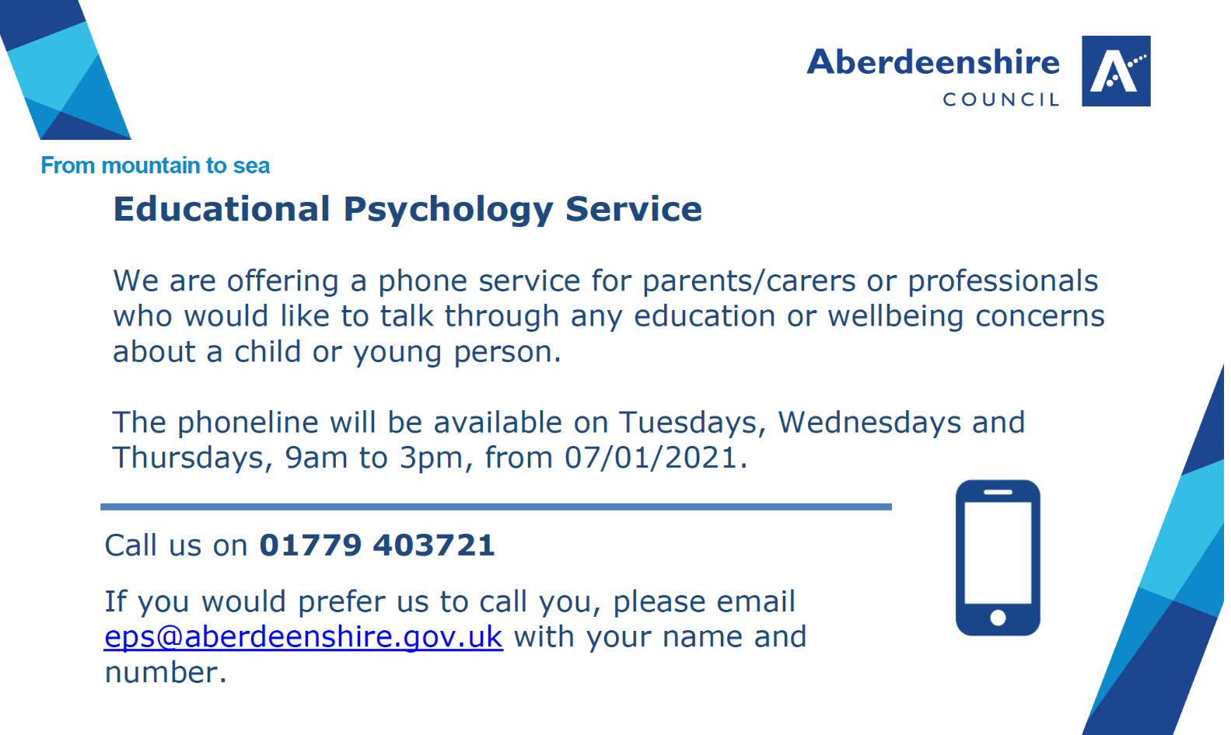

Active Schools: keeping children and adults active during lockdown
Football Skills with Andy Session 1: https://youtu.be/rkqEz7MjhFM
Football Skills with Andy Session 3: https://youtu.be/iug96b8OlUQ
Boxercise with Shona - Session 2: https://youtu.be/JP9raoryhdo
Let’s Dance with Fiona – Video 3: Move Your Body: https://youtu.be/6b97XgCMS08
Boxercise with Shona - Session 4: https://youtu.be/y6ei5N5fKgI
Fun Fitness with Ashleigh Session 2: https://youtu.be/bbIhLMqLpbQ

If boxercise and dance aren’t quite your thing then check out these resources from our colleagues at Basketball Scotland.

Junior NBA Resources: Jr. NBA at Home - NBA.com: Jr. NBA

Alternatively, Live Life Aberdeenshire are currently running a Winter Wellbeing theme on the Live Life at Home website with ideas on how to stay well with winter.

Winter Wellbeing, Live Life at Home: https://www.livelifeaberdeenshire.org.uk/live-life-at-home/winter-wellbeing/
Active Schools Resource Cards - http://bit.ly/ASAResourceCards or http://bit.ly/ASACreativeCards

Run 4 Fun 2021
We have launched our new Virtual Fun Run series, “Run4Fun2021”. Bookings are open to register. Every participant who takes part in the series will receive a custom designed medal and a certificate of achievement.

There are a total of four monthly runs between February and May however participants only need to complete one run to receive a medal and certificate.
It only costs £2 (+0.71p booking fee) to take part in the whole series and sign ups can be made online via this link: https://bit.ly/ApplyforRun4Fun2021

Aberdeen Football Community Trust resources
Please find a link below to the Aberdeen Football Community Trust resources DONline Learning resources.

https://www.afccommunitytrust.org/donline-learning-3/donline-learning-2/

Scottish Apprenticeship week
Scottish Apprenticeship Week is for all S3, S4, S5 & S6 pupils. Young professionals UK are hosting a virtual event with 7 of their biggest clients who have a huge hiring presence in the Scottish region on the 1st March, 4pm - 6pm.

They have teamed up with EY, GSK, QA, HSBC, PwC, Capgemini & RAF all of which will be delivering a 15-minute workshop / session on who they are, what they do and career opportunities for pupils. Each company will be joined by one of their very own apprentices who will share their career journey to date along with someone from the recruitment team to share information on the different opportunities / route paths post-School. There will be a big focus on Graduate Apprenticeships and Work Experience opportunities, many of which will be live and open for your students to apply to straight away.

Webinar Details:
- Monday 1st March, 4pm - 6pm
- 8 different Apprentice highlight journeys and workshop sessions
- Open to all year groups in S3, S4, S5 & S6
- Opportunity to ask questions and find out about other young people's career journeys
- Big focus on Graduate Apprenticeships and Summer Work Experience
- Learn about different types of apprenticeships, some myth busting and a few prizes along the way!
- Free event for all pupils, teachers and parents

Application Link:
https://www.research.net/r/Scottish-NAW

Contacting TGS & Accessing Aberdeenshire Council Services
Please either download the‘MyAberdeenshire’ app for your phone / device or register on-line at ‘MyAberdeenshire’ to access services provided by Aberdeenshire Council.
https://www.aberdeenshire.gov.uk/my

Services include iPay payments (‘School payments’ including paying for school meals, services and activities); ‘Parents Portal’; School Closures and Term dates,
for example.

Please use the following to contact The Gordon Schools:

The Gordon Schools
Huntly
AB54 4SE

Phone (available 08:00 – 17:00): 01466 405990 (note: new number)

You will be given two options:
Option 1: To report an absence (only between 08:00 – 17:00)
Option 2: All other enquiries

From 17:00-08:00 there is a voicemail service for you to leave a message (absence or otherwise) and we will respond to this as soon as we can.

Web: http://www.gordonschools.aberdeenshire.sch.uk

E-mail: gordonschools.aca@aberdeenshire.gov.uk

Finally…
The nights are starting to get lighter…the Covid vaccine is being rolled out…we’re very slowly starting to get more pupils and colleagues back into TGS…let’s hope that this is the start of more good things to come!...

Best wishes to all,

Phil

Phil Gaiter
Rector
The Gordon Schools
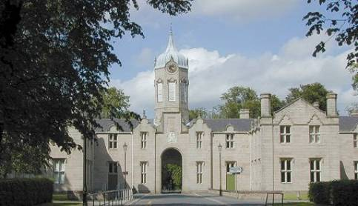
phone: 01466 405 990
e-mail: gordonschools.aca@aberdeenshire.gov.uk

