THE GORDON SCHOOLS

Lunchtime
and
After-School Activities

2021 – 2022

Including some other agencies offering activities, advice and support to pupils and parents.

Why Take Part in Extra-curricular Activities?

- Meet new people.
- Make new friends.
- Learn new skills.
- Shared interests.
- Find new interests and experiences.
- Experience new environments.
- Encourage independence.
- Share your talents and appreciate other people’s talents and abilities.
- Help with school subjects.
- Build confidence.
- Improve communication.
- Meet, and be, a positive role model.
- Learn to be mindful.
- Learn to relax and unwind.

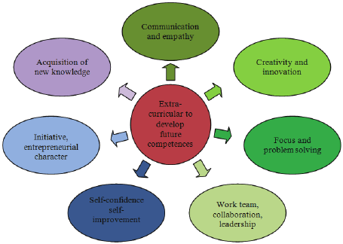
Activities by Day

Monday
Badminton 3.45 – 4.45 pm page 7
Film Club 1.20 – 2 pm page 2
Geography Drop-In 1 – 2 pm page 2
Modern Languages 1.25 – 2 pm page 5
Music 1.30 – 2 pm page 5
Rugby 1.20 – 1.50 pm page 7
Social Club 1.20 – 1.50 pm page 8
Volleyball 1.20 – 1.50 pm page 7

Tuesday
Boys Football 1.20 - 1.50 pm page 7
Computer Club 1.20 – 1.50 pm page 1
Eco Group 1.15 – 2 pm page 2
Knitting and Crochet 1 – 2 pm page 3
Modern Languages 1.25 – 2 pm page 4
Music 1.30 – 2 pm page 5
Netball 1.20 – 1.50 pm page 7
Ultimate Frisbee 1.20 – 1.50 pm page 7

Wednesday
BandLab2 1.15 – 2 pm page 6
Board and Card Games 1.15 – 2 pm page 1
Film Club 1.20 – 2 pm page 2
Cheerleading 1.20 – 1.50 pm page 7
History Drop-In 1 – 2 pm page 3
Girls Football 1.20 – 1.50 pm page 7
Modern Languages 1 25 – 2 pm page 4
Origami 1.20 – 1.55 pm page 6
Music 1.30 – 2 pm page 5
Activities by Day

Wednesday (continued)
Relax Kids 1.20 – 1.50 pm page 8
Rugby 4 – 5 pm page 7
Scripture Union 1.10 – 2 pm page 8
Sustainable Sewing 1 - 2 pm page 9

Thursday
Board and Card Games 1.15 – 2 pm page 1
Climbing 1.20 – 1.50 pm page 7
Computer Club 1.20 – 1.50 pm page 1
LBGT+ 1 – 2 pm page 4
Modern Languages 1.25 – 2 pm page 4
Netball 4 – 5 pm page 7
Volleyball 1.20 – 1.50 pm page 7

Friday
Chess Club 1.15 – 2 pm page 1
Girls Hockey 1.20 – 1.50 pm page 7
Sewing Club 1 – 2 pm page 9

Found something that interests you?
Head to the page to see what it’s all about!


Board Games/Card Games Club

Mrs Dixon and Mr Wood
D7, every Wednesday, 1.15 pm
B15, every Thursday, 1.15 pm
Bring your own cards or choose from a selection of games.



Chess Club

Mr Morrison
Friday, 1.15 pm in the library
Beginner or expert, all are welcome.


1
Computer Club

Mrs Paterson
A12, every Tuesday and Thursday
1.20 – 1.50 pm

Eco Group

Mrs McLeod
Tuesday, 1.15 pm in A21
Bring your own lunch.
All welcome.

Film Club

Freya Wilson, S6
Drama Department, Monday/Thursday 1.20 pm

If you are interested in acting, directing, sound production, cinematography or making films, then Film Club is the place for you.

2
Geography Drop-In

Miss Bruce & Mr Burgess
Monday lunchtimes

Come along if you have questions, need help or if you just need space and time to complete your Geography homework.

History Drop-In
National 5 and Higher

Mrs Morrison
Wednesday lunchtime

Come along if you have questions about the content or skills, or just use the space to complete your History homework, knowing you can ask for help if needed


3
Knitting and Crochet Club
Pins and Needles

Mrs Fairweather, Mrs Emslie, Mrs Gray,
Mrs Morrison
Library, Tuesday lunchtime, 1 – 2 pm
Come along if you knit or crochet, or if you would like to learn. Bring your lunch.

LGBT⁺ Club

Mr Cholet
Thursday, A23
The LGBT+ club will take place during lunch time so bring your lunch. For those who don't know where to go, come and ask Mr Cholet in A23. Everyone is welcome.

Modern Languages Support

Mrs McLeod
Monday, Wednesday, and Thursday
A21, 1.25 pm

4
Music Department

Mrs Moir/Miss Eleftheriadi
Due to current regulations, we are restricted as to what we can offer.

There will be no groups singing or wind instruments until further notice.

There will be no school show this year. Hopefully we can come back with a show in 2022.

Practice Rooms are available, daily, for pupils who receive lessons in school and for senior pupils studying music at N5/H/AH – see the booking sheet outside S8.

Mrs Moir (S8) and Miss Eleftheriadi (S11) are offering spaces to a small number of pupils in S1 – 3 at 1.30 pm starting Monday 30 August. Come along practise an instrument or get some help on the following days:

S1 Monday S11
S2 Tuesday S11
S3 Wednesday S11

Mr McCash will run a percussion group on Wednesday at 1.30 pm. This is for pupils who receive percussion lessons, but there will be room for others who are interested.

5
Music Department (continued)

BandLab2
Wednesday, 1.15 pm, in the Flat
Learn how to use music technology in a fun and creative way. Pupils, if possible, should bring their own headphone with a small adapter.

S1 Music Club
S3, 1.30 pm
Come along to practise or learn new skills.

Origami Club

Mr Folgado Casado
Wednesday, Library, 1.20 – 1.55 pm
Origami is about symmetry and paper folding. In this club you will learn how to unwind while we make popular Origami items. All creative minds are welcome to join!


6
PE Department and Active Sports

Monday
S1 – 3 Volleyball Mrs Harper
1.20 – 1.50 pm
S1 – 6 Rugby Mr Beadle/Mr Sutcliffe
1.20 – 1.50 pm
S1 – 6 Badminton Mrs Mitchell
3.45 – 4.45 pm
Tuesday
S1 – 3 Netball Miss Riddell
1.20 – 1.50 pm
S1 – 3 Boys Football Dr Organ/Senior Pupil
1.20 – 1.50 pm
S1 -6 Ultimate Frisbee Mr Wood
1.20 – 1.50 pm
Wednesday
S1 – 3 Girls Football Mrs Milne/Senior Pupil
1.20 – 1.50 pm
S1 – 6 Cheerleading Miss Riddell/Mrs Robertson
1.20 – 1.50 pm
S1 – 4 Rugby Mr Beadle
4 – 5 pm
Thursday
Volleyball Mrs Harper
1.20 – 1.50 pm
S1 – 6 Climbing Mr Maharg
1.20 – 1.50 pm
S4 – 6 Netball Miss Riddell
4 – 5 pm
Friday
S1 -6 Girls Hockey Mrs Milne/Mrs Mitchell
1.20 – 1.50 pm

7
Relax Kids

Sharon Spiers
Wednesday
Drop in, Health Hub, 1.20 – 1.50pm.
All Welcome.


Scripture Union

Mr Blackburn
Thursday, G4, 1.10 pm
SU stands for Scripture Union and is a group for Christians and anyone who has questions about the Christian faith. Everyone welcome. Bring your lunch.

Sewing Club

Mrs Lee
Friday, B30
Maximum of 6 people at any one time

8
Social Club

Mrs Robertson and Mrs Mills
Monday, G6, 1.20 pm
If you would like to meet new people and have a chat and some fun, please come along.


8
Sustainable Sewing

Ms Rae/Mrs Chalmers
This will focus on the theme of sustainability and the recycling of fabrics into something ‘new’. Did you know that 85% of textiles goes to landfill every year adding to carbon emissions? Recycle, reuse, and repurpose.

Wednesday 1 pm in B30, Design Room
Maximum 10 pupils
All year groups.

9
The Following Agencies
Offer Activities and/or
Advice and Support
to Pupils and Parents

Aberdeenshire Council
Employability Service

A Supported Employment Service for people with disabilities and health related conditions, enabling people to achieve their goals.

Goals can be - paid employment
work experience
voluntary work
self-employment
training
job retention

Help with - confidence building
work choice programme

To find out more call 07733115929
Aberdeenshire Libraries
Local Public Library Opening Times

The Brander Library, Huntly (01466 405590)
Monday: 10 am – 1 pm Limited Browsing
Wednesday: 10 am – 1 pm Click and Collect
Friday: 3 – 6 pm Click and Collect
Saturday 10 am – 1 pm Limited Browsing

Insch Public Library (01464 635190)
Tuesday: 2 - 4 pm Click and Collect
Friday: 2 – 4 pm Click and Collect

As a member, you have 24/7 access to the library and in many cases, from home, to the following:
- access to computers
- download e-books, audio books, music and video
- access to encyclopaedias
- family history
- newspapers and journals
- driving test materials
- dictionaries
- e-magazines
- music from Freegal.

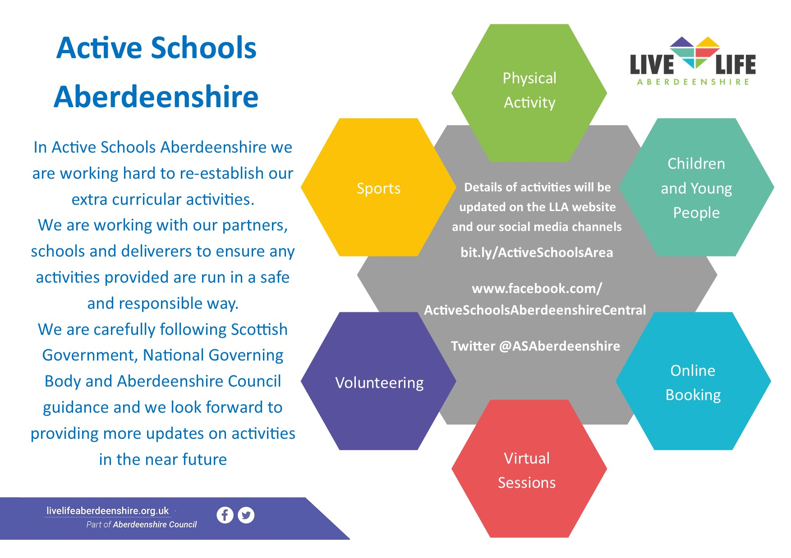
Active Schools

Awareness | Inclusion | Understanding | Acceptance
Unit 2, Steven Road, Huntly AB54 8SX

Huntly ASDitude is a local, independent, parent led charity.
We provide Peer Support for children & families who are affected by Autism, AD(H)D and/or other related conditions living in our local community.
We organise and facilitate Groups, Events & Activities that are 'Multi Support Needs' friendly, providing social opportunities and experiences in a safe, accepting, non-judgmental environment.
OUR AIMS:
- Facilitate social events & opportunities
- Raise awareness
- Connect with the local community
- Signpost to other appropriate agencies
- Promote inclusion
- Support parents/carers & share experiences


If you are a Parent or Carer of a child affected by Autism, AD(H)D and/or other related conditions, please feel free to join our ‘Closed’ Facebook Support Group: www.facebook.com/groups/HuntlyASDitude/


If you would like to follow our Public Page, you’ll find us here: www.facebook.com/HuntlyASDitude

CONTACT US:
Email: Huntly_ASDitude@outlook.com

Website: www.huntlyasditude.btck.co.uk


Phone: 07488 266 271

Huntly’s New Single Point of Access

Drug & Alcohol Third Sector Partnership Service Providers

A new single point of access service is provided by a third sector partnership comprising of Drugs Action, CAIR Scotland, Turning Point and Aberdeen Foyer.

These organisations all deliver services at different stages of recovery and the aim of the project is to try and extend their reach in the community. The single point of access will provide people with one place where they can go for information, advice, and support either for themselves or for someone in their family.

It is now open at Largue’s Pharmacy, Gordon Street, Huntly. The drop-in service, delivered by Drugs Action, offer’s specialist testing, Naloxone Training, and a needle exchange. /

Drugs Action Contacts:


In addition to the new Single Points of Access there are services available throughout Aberdeenshire to help people who are stable in their recovery but require further support to help them move on.



CAIR Scotland operate the Aberdeenshire Community Recovery Service whose interventions focus on supporting people to recover in their communities and decrease reliance on specialist substance use services, providing a positive exit from the Substance Use Service. Interventions at this stage support people to grow and sustain their recovery through social skills development, personal awareness, Wellness & Recovery Action Planning and gaining new skills and experiences that can support moving on. This stage is community based, helping people to engage or re-engage with social and leisure activities, mutual aid and family support. Also 1:1 work is offered on a person-centred approach tailored to meet the individual’s needs

CAIR Scotland’s Contacts
Office: 01467 624240
Andrea Fraser, Service Manager: 07850724147 or Diane Ord, Development Worker: 07709483283



Aberdeen Foyer offer support for individuals/families recovering from addiction, as well as improving employability and supporting people into education, training, and employment. This is done on a 1:1 basis offering support tailored to meet the individual needs. They will help with a variety of issues that are barriers to moving on including housing, debt etc. Whilst they will not deliver all of this they have close links to support organisations and will ensure individuals have the confidence to attend, taking them to the first appointment if necessary. Appropriate referrals would be people who would like to work, do training or further education, although this may be quite a long term goal. They also provide the new REACH programme within the Shire.

Aberdeen Foyer’s Contact
Office: 01224 212924
Loraine Stephen, Service Manager: 07876860562

GENERAL SCHOOL INFORMATION

Free School Meals
The pupil will receive a daily credit allowance to the value of a 2-course meal chosen from the menu. To request an application form or make an enquiry, call 01467 533400.

School Clothing Grant
To find out if you may be eligible for a grant, call 01467 533400
or
e-mail: fsm@aberdeenshire.gov.uk

Educational Maintenance Allowances (EMA)
Ask your Guidance Teacher about eligibility and for an EMA application form. Alternatively, you can e-mail: ema@aberdeenshire.gov.uk

EDUCATIONAL TRUSTS

ABERDEENSHIRE EDUCATIONAL TRUST
The Aberdeenshire Educational Trust can provide financial assistance towards the cost of some Educational trips. The awards aim to promote education in visual art, music and drama, and are usually made to schools. The Trust has limited resources and in the interests of fairness, all applications received are means tested. Awards are not granted to individuals whose household income exceeds £20,525.

HUNTLY EDUCATIONAL TRUST
The Huntly Educational Trust is a Trust for the distribution of funds for educational purposes within the Huntly area.
IRONSIDE MEMORIAL ENDOWMENT
Mr Ronald Ironside late of Ottawa, Canada, and a former pupil of The Gordon Schools, made a provision in his will for the establishment of an endowment fund to provide a bursary to enable further education in the sciences in respect of those students attending The Gordon Schools.

GORDON RURAL ACTION
HUNTLY HUB

Gordon Rural Action offers a wide range of free, confidential, impartial and independent advice and digital access on a range of issues including Scottish Security Scotland Benefit applications, (Best Start Grants, Best Start Food Card, Carers Supplement, Young Carers Grant, Funeral Support Payment), Scottish Welfare Fund Applications, Universal Credit Applications and Journal updates, Warm Home Discount, Blue Badge Application, Housing Applications (e.g. Apply4Homes), Council Tax Reduction / Housing Benefit. They are also the home to the School Uniform Exchange providing free school uniform to pupils attending schools in and around Huntly.

Contact: Advice@GordonRural.Org.uk
Tel: 01466 793676

NETWORKS OF WELLBEING LTD

Networks of Wellbeing (NoW) is an inclusive and diverse organisation which promotes and supports people in improving their mental health and wellbeing.

Based in Huntly, NoW offers a community based service centred around the Five Steps to Wellbeing approach to good mental health.

We continue to develop the range of supports we offer (most of which are, at present, free at the point of delivery). Our and current services and activities include:
- AB54 Community Newsletter.
- Chilling Women aromatherapy group.
- Counselling (confidential and free to anyone aged 18 and over - counselling for children under 12 will be available soon).
- Cycling Connections - bike based projects and activities.
- CST & Dementia support - Cognitive Stimulation Therapy (for people with mild to moderate levels of dementia); support for families of people living with dementia.
- Drop-in support - on hold due to coronavirus pandemic (will open again in the future).
- IT Support - for people unfamiliar with IT and wishing to join our online activities.
- Mindfulness sessions.
- Monthly Tea Dance - on hold due to Coronavirus pandemic.
- NoW Jogging Group.
- Peer Support Group.
- Relaxation.
- Silver Singers - on hold due to coronavirus pandemic (will start again when possible).
- Telephone 1:1 support - for people unable to join our Peer Support sessions.
- Veterans Pathways to Recovery - support for Veterans, their families, and carers.

Networks of Wellbeing Ltd
The Clashmach Centre, 18 Steven Road, Huntly AB54 8SX
Telephone 01466 793732 or email info@networksofwellbeing.org

Fiona Alderson
Service Manager
PLEASE NOTE THAT STAFF ARE CURRENTLY WORKING FROM HOME AND THAT THE OFFICE PHONES HAVE BEEN DIVERTED.
THIS MEANS WE ARE ABLE TO ANSWER YOUR CALLS BETWEEN 9AM AND 3PM MONDAY TO FRIDAY.
(Usual working hours - Tuesday to Friday 9am to 4:00pm)

- 
JOBCENTRE PLUS

Buckie Jobcentre Plus
Shanks Lane
Buckie
AB56 1AF

Telephone: 0345 604 3719
Textphone: 0345 608 8551

Get assistance for:

- finding a job
- changing an appointment
- checking existing claims
- making new claims

I offer Children & Adults support with their Mental Health and Well-being.

Relax Kids is a Unique 7 Step Programme that can help to
boost concentration, self-esteem, and confidence. It can also help to improve peer relationships and socials skills.

You will learn different techniques to help you deal with anxiety and stress. We all have busy lives and/or worries from time to time. The sessions will help you to deal with them in a safe and nurturing environment.

Wednesday
Drop in, Health Hub, 1.20 – 1.50pm.
All Welcome.

I can offer a 4-week block of Just Relax sessions for Staff after school and if any parents are interested, I could run some Just Relax sessions for parents. If you want to give it a go, email me at the address below.

Sharon Spiers

Email : sharon.speirs@aberdeenshire.gov.uk

Skills Development Scotland
Careers Adviser: Lisa O’Brian
(available in school 3 days per week)
Skills Development Scotland
Unit 6
Garioch Centre
Constitution Street
Inverurie
AB51 4UY
Tel 01467 623623

Please use the Skills Development Scotland website on www.sds.co.uk

See also our interactive website www.myworldofwork.co.uk - to support career planning.

SDS works with pupils, school leavers and adults.

(Careers resources are available in the school library. Pupils who are considering leaving school or who simply wish to be aware of opportunities in the area, should ask to receive regular updates. Ask the librarian for help if you cannot find the information you require.)
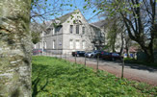
The Linden Centre
Community Learning and Development

Community Learning and Development Service supports groups and individuals to fulfil their potential, as active learners and citizens. The team that supports the Huntly area works with partners in the community as well as young people and adult learners. Bespoke learning opportunities are offered as the needs are identified, ranging from literacies and ICT support, employability, ESOL, volunteering etc. Most of the learning offers an SQA qualification as an integrated option. Learning is delivered face to face and online.

For more information visit:

https://www.facebook.com/search/top?q=adult%20learning%20aberdeenshire
Or/
Or contact one of our staff.

Roisin.Daly@ aberdeenshire.gov.uk
Senior CLD worker- Community Development

Kate.James@ aberdeenshire.gov.uk
Senior community Worker - Working with Young People

Lada.Copic@ aberdeenshire.gov.uk
Senior CLD worker - Adult Learning

Huntly Swimming Pool

Huntly Swimming Pool

Fitness Room Inductions:
Huntly Swimming Pool has a fitness room with a variety of equipment including free weights, cardio, and resistance machines. Anyone over the age of 16 can sign up for free – with various options for payment including pay as you go or pay monthly access options.

National Pool Lifeguard Qualifications
The pool also run NPLQ courses, which gains the lifeguarding qualification required to work as a lifeguard at any pool in Britain.

For more information on any of these – email

huntly.swimmingpool@aberdeenshire.gov.uk

